**“DESIGN OF NOVEL ALGORITHM IN CONTEXT TO NEWS CORPUS & TEXT SUMMARIZATION”** (UDP)

*Submitted by*

Aniket C Patel

(160950107055)

Upasana V Kalra

(160950107033)

*Under the Guidance of*

Mrs. Madonna Lamin

Head of Department

Computer Science and Engineering

*Project report submitted*

*in fulfillment of the requirement for the degree of*

Bachelor of Engineering

In

Computer Science and Engineering



Department of Computer Science and Engineering

Institute of Technology and Management Universe

Paldi Village, Vadodara - 391510



SEMESTER VIII

**ACADEMIC YEAR: 2019-20**

**Certificate**

This is to certify that report submitted along with the project entitled “**DESIGN OF NOVEL ALGORITHM IN CONTEXT TO NEWS CORPUS & TEXT SUMMARIZATION**” has been carried out by “**Aniket Patel (160950107055) & Upasana Kalra (160950107033)**” under my guidance in fulfillment for the degree of Bachelor of Engineering in Computer Science and Engineering – VIIIth Semester of Gujarat Technological University, Ahmedabad during the academic year 2019-20. These students have successfully completed the project activity under my guidance.

INTERNAL GUIDE HEAD OF DEPARTMENT

Mrs. Madonna Lamin Mrs. Madonna Lamin

**Declaration**

We **Aniket Patel** and **Upasana Kalra** the student of Computer Science and Engineering, having enrollment number **160950107055** & **16095010733** enrolled at ITM Universe, Vadodara hereby certify and declare the following:

1. We have defined our project based on inputs at **ITM Universe** and each of us will make significant efforts to make attempt to solve the challenges. We will attempt the project work at my college or at any location under the direct and consistent monitoring of **Mrs. Madonna Lamin**. We will adopt all ethical practices to share credit amongst all the contributors based on their contributions during the project work.

2. We have not purchased the solutions developed by any 3rd party directly and the efforts are made by me/we under the guidance of guides.

3. The project work is not copied from any previously done projects directly.

4. We understand and accept that the above declaration if found to be untrue, it can result in punishment/cancellation of project definition to we including failure in the subject of project work.

Name(s): Aniket Patel Signature

Upasana Kalra Signature

Contact Number(s): 9408356985

7487800779

Date: 26/05/2020

Place: Vadodara

**Acknowledgement**

We would like to express our gratitude and appreciation to all those who supported us to complete this report. A special thanks to our project coordinator, whose help, stimulating suggestions and encouragement, helped us to coordinate our project work – **DESIGN OF NOVEL ALGORITHM IN CONTEXT TO NEWS CORPUS & TEXT SUMMARIZATION** as part of Bachelor of Engineering in the Department of Computer Science and Engineering.

We would also like to acknowledge with much appreciation the crucial role of the Head and staff of Computer Science Department for their contribution in our project work.

We would like to thank our Internal Guide **Mrs. Madonna Lamin**, who has given her full effort in guiding the team in achieving the goal as well as encouragement to maintain our progress in track. We would like to express our gratitude for the guidance given by other supervisors as well as the panels especially in our project presentation that has improved our presentation skills by their comments and tips.

Lastly, we are deeply indebted to the College for providing us immense support in all aspects especially in our project work.

**ABSTRACT**

In this new era, tremendous information on the World Wide Web and in other electronic form is increasing tremendously. It is very difficult for human beings to manually extract the summary of such large text. So, it is most important to provide the improved mechanism to extract the information quickly and most efficiently. In order to solve the above problem, the automatic text summarization is very much necessary. Text summarization is the process of identifying the most important meaningful information in a document or set of related documents and compressing them into a shorter version preserving its overall meanings. As large amount of web content is news. News websites are daily overwhelmed with plenty of news articles. For this reason, we have present an effective approach for single document news article summarization to help people obtain the most important information in the shortest time.

**LIST OF FIGURES**

|  |  |  |
| --- | --- | --- |
| 1 | Figure-I Timeline chart……………………………………………………….. | 5 |
| 2 | Figure-II Use Case Diagram………………………………………………….. | 7 |
| 3 | Figure-III Sequence Diagram……….……………………………………….. | 8 |
| 4 | Figure-VI Class Diagram…………………………………………………….. | 9 |
| 5 | Figure-V ER Diagram……………….……………………………………….. | 10 |
| 6 | Figure-VI Context Diagram………………………………………………….. | 11 |
| 7 | Figure-VII Data Flow Diagram..…………………………………………….. | 11 |
| 8 | Figure-VIII State Transition Diagram……………………………………….. | 16 |

**TABLE OF CONTENTS**

|  |  |
| --- | --- |
| TITLE PAGE ………………………………………………………...............…….. | i |
| CERTIFICATE………………………………………………………............…….. | ii |
| DECLARATION…………………………………………………………….…….. | iii |
| ACKNOWLEDGEMENT…………………………………………………...…….. | iv |
| ABSTRACT………………………………………………………….............…….. | v |
| LIST OF FIGURES ……………………………………………………………….. | vi |
| TABLE OF CONTENTS………………………………………………..………… | vii |
| 1. INTRODUCTION……………………………………………………………….. | 1 |
| 1.1 Project Summary…………………………………………………………….. | 1 |
| 1.2 Aim and Objective of the Project…………………………………………….. | 1 |
| 1.3 Problem Specifications………………………………………………..…….. | 1 |
| 1.4 Literature Review……………………………………………………...…….. | 2 |
| 1.5 Plan of Work…………………………………………………………..…….. | 2 |
| 2. SYSTEM REQUIREMENT STUDY……………………………………...…….. | 4 |
| 2.1 User Characteristics………………………………………………………….. | 4 |
| 2.2 Hardware and Software Requirements………………………………...…….. | 4 |
| 2.3 Constraints……………………………………………………………..…….. | 4 |
| 2.4 Timeline Chart……………………………………………………………….. | 5 |
| 3. SYSTEM ANALYSIS…………………………………………………….…….. | 6 |
| 3.1 Study of Current System…………………………………………………….. | 6 |
| 3.2 Problems and Weaknesses of Current System……………………………….. | 6 |
| 3.3 Requirements of New System………………………………………….…….. | 6 |
| 3.4 Feasibility Study……………………………………………….............…….. | 6 |
| 3.5 Functions of System…………………………………………………...…….. | 7 |
| 3.5.1 Use Cases and Sequence Diagram………………………………..……. | 7 |
| 3.6 Data Modelling………………………………………………………..…….. | 9 |
| 3.6.1 Class Diagram and E-R Diagram……………………………….…….. | 9 |
| 3.7 Functional and Behavioral Modelling…………………………...........…….. | 11 |
| 3.7.2 Data Flow Diagram (0-1 Level)………………………………... …….. | 11 |
| 3.8 Main Modules of New System……………………………………………….. | 11 |
| 3.9 Selection of Hardware and Software and Justification……………………….. | 12 |
| 4. SYSTEM DESIGN………………………………………………………...…….. | 13 |
| 4.1 System Procedural design…………………………………………………... | 13 |
| 4.2 State Transition Diagram...………………………………………………….. | 16 |
| 5. Implementation Planning and details…………………………………………….. | 17 |
| 5.1 Implementation Environment………………………………………………... | 17 |
| 6. Testing…………………………………………………………………………… | 19 |
| 6.1 Testing Plan………………………………………………………………….. | 19 |
| 6.2 Testing Strategy……………………………………………………………… | 20 |
| 6.3 Testing Methods……………………………………………………………... | 20 |
| 6.4 Test Cases……………………………………………………………………. | 21 |
| 7. Screen Shorts and User Manual………………………………………………….. | 33 |
| 8. Conclusion………………………………………………………..............……… | 46 |
| References……………………………………………………………............…….. | 47 |
| Appendix-A…………………………………………………………………..…….. | 48 |
| Appendix-B…………………………………………………………………..…….. | 52 |
| Appendix-C…………………………………………………………………..…….. | 57 |

1. **INTRODUCTION**

Before going to the Text summarization, first we, have to know that what a summary is. A summary is a text that is produced from one or more texts, that conveys important information in the original text, and it is of a shorter form. The goal of automatic text summarization is presenting the source text into a shorter version with semantics. The most important advantage of using a summary is it reduces the reading time. Text Summarization methods can be classified into extractive and abstractive summarization. An extractive summarization method consists of selecting important sentences, paragraphs etc. from the original document and concatenating them into shorter form. An Abstractive summarization is an understanding of the main concepts in a document and then express those concepts in clear natural language.

There are two different groups of text summarization: *indicative* and *informative.* Inductive summarization only represent the main idea of the text to the user. The typical length of this type of summarization is 5 to 10 percent of the main text. On the other hand, the informative summarization systems gives concise information of the main text .The length of informative summary is 20 to 30 percent of the main text .

* 1. **PROJECT SUMMARY**

Propelled by the modern technological innovations, data is to this century what oil was to the previous one. Today, our world is parachuted by the gathering and dissemination of huge amounts of data.

With such a big amount of data circulating in the digital space, there is a need to develop an algorithm that can automatically shorten longer texts and deliver accurate summaries that can fluently pass the intended messages. So, we have developed a feature-based extractive summarization algorithm.

Hence, we have also developed Text Summarizing tool named Summify – Summarization Simplified that will generate the summary of single document news articles of popular news website like CNN, BBC, Reuters, NY times, etc. Along with summary, it provides top ranked keywords of that news articles.

**1.2 AIM & OBJECTIVE OF PROJECT**

The main objective of a text summarization system is to create an abstract of the entire news article or a representative summary by finding the most informative and relevant sentences.

**1.3 PROBLEM SPECIFICATION**

Current Summarization system don’t have ability to detect implicit relationships between terms within document. For example, appearance of entities such as “Hiroshima”, “Nagasaki” and “Atomic Bombing” should be found to be related if all appeared within document or set of document.

Secondly, generating summary manually is a hard task to perform. We as humans have tendency to generate summary bias to importance and might skip important topics just to reduce length of any topic.

**1.4 LITERATURE REVIEW**

***Single Document Summarization****:* Various technical documents were focused in single-document summarization. Luhn in 1958 shows the significance of words based on frequency measures. He deleted the stop words and rest words are given a hierarchy starting from root and index describes the significance of each word. This is calculated on the number of occurrences in a document called as significant factor and are ranked. Based on ranking top sentences are selected to form a summary.

Baxendale in 1958 focused on sentence position to find the salient features. He took 200 paragraphs and examined that in 85% of paragraphs topic sentences are placed in the beginning while in rest 7% he found, it occurred in the last.

Edmundson in 1969 proposed a typical structure that produces extracts. In the beginning he took around 400 technical documents and build a protocol producing manual extracts. He addressed the above two features (word frequency, word position) and gave the two new features named cue words and skeleton (title or heading). Also the weights were attached with these. He evaluated and found that 44% machine extracts matched with manual extracts.

***Multi-Document Summarization****:* The major contribution was done by McKeown and Raedev in 1995 (NLP group) at Columbia University and SUMMONS was build. Similarity measures were used and extractive techniques were applied. McKeown in 1999 and Raedev in 2000 identified common themes using clustering while Barzilay in 1999 produced composite sentences from cluster whereas Carbonell and Goldstein in 1998 used maximal marginal relevance (MMR). A major contribution where multi-document summarization was concatenated to multilingual environment by Evans in 2005.

* 1. **PLAN OF WORK**

**Activity_1:** Planning & Deciding

**Description:** Designing of algorithm for extracting most important information from news articles.

**Time Duration:** 2 weeks (December)

**Activity_2:** Collecting news Article from news corpus

**Description:** Using news corpus, news articles are extracted and applied Text Preprocessing.

**Time Duration:** 15-20 days (Jan)

**Activity_3:** Implementation of algorithm

**Description:** Coding for designed algorithm

Time Duration: 2 months (Jan – Feb)

**Activity_4:** Testing and Evaluating

**Description:** Evaluating of Accuracy and Precision score

**Time Duration:** 10-15 day (Feb)

**Activity_5:** Product Development

**Description:** Making of Summify Application for Android and Web which will extract news articles from web and generates summary for the same.

**Time Duration:** 1 month (Feb - March)

1. **SYSTEM REQUIREMENT STUDY**

**2.1 USER CHARACTERISTICS**

* Professor
* Researchers
* Students
* Employees
* News Media
* Educational Institutes
* Companies
* Courts
* Lawyer
  1. **HARDWARE & SOFTWARE REQUIREMENTS**
* **Hardware**

1. Computer / Smartphones / Laptop
2. Internet connectivity

* **Software**

**Language-**

1. Python
2. Java

**Tools-**

1. Pycharm
2. Android Studio
   1. **CONSTRAINTS**

* The system which we have developed, summarizes only single document news article. So, there is a need to extend its functionality to summarize multiple documents together.
* It works on English Language only.
* It requires text and title both as an input for news articles.
  1. **TIMELINE CHART**

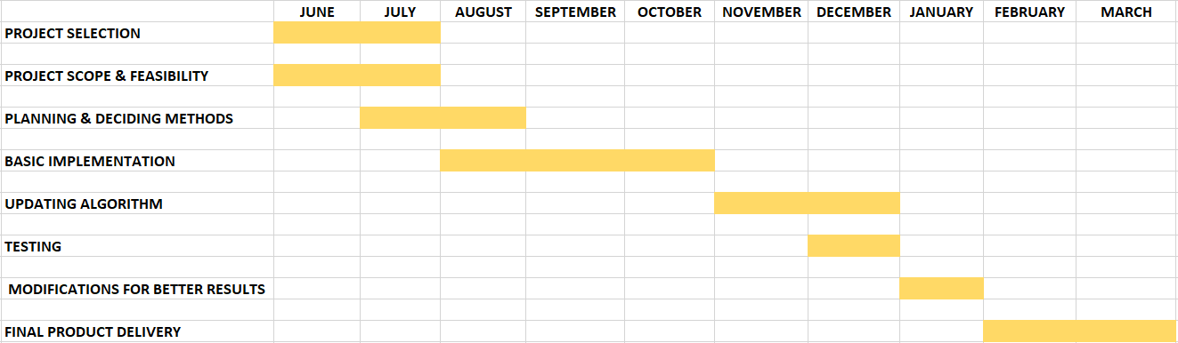

Figure-I Timeline Chart

**3. SYSTEM ANALYSIS**

* 1. **STUDY OF CURRENT SYSTEM**

Till today summary of any content is generated by humans itself. This causes problems like longer time for summary generations, looking whole text, understanding it and then selecting important sentences. This becomes tiresome job to do.

* 1. **PROBLEMS & WEAKNESS OF CURRENT SYSTEM**

There are few Text Summarization tool that generates summaries but they still needs improvement like few tool can’t relate between words (i.e. Semantic meaning). Also summaries generated are not grammatically correct because in few tools sentences are selected randomly. Thus losing the actual paragraph framing.

* 1. **REQUIREMENT OF NEW SYSTEM**

Generating summaries manually becomes time-consuming and hectic process. Thus it is necessary to have such system that can generate summaries for us on-the-go and can retain actual meaning of the content.

**FUNCTIONAL REQUIREMENT**

* System should be able to generate summary for given input text, document, url of Wikipedia.
* System should be able to generate summary for given url of News Article and also it should display the whole article along with summary and top keywords.
* It should display error message if given text is too small to process.

**NON-FUNCTIONAL REQUIREMENT**

* System designed should remain available 24*7.
* Multiple users should be able to access the system altogether at given point of time.
* The summary generated should be able to copied, download and can be shared with anyone through social media.
* System should work with Firefox 5, Internet Explorer 8, Google Chrome 12, and Opera 10
  1. **FEASIBILTY STUDY**

Summarization tool that we have made is Cost efficient as user don’t have to invest much for using this tool. A normal Internet connectivity is required to use our android or web application that we have developed. Also, the system is easy to use and it generates summary on 1 click.

* 1. **FUNCTIONS OF SYSTEM**

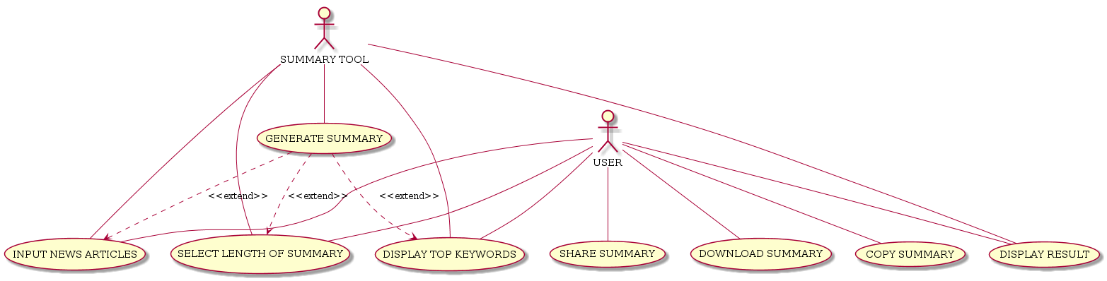

Fig 3.5.1 Use Case Diagram

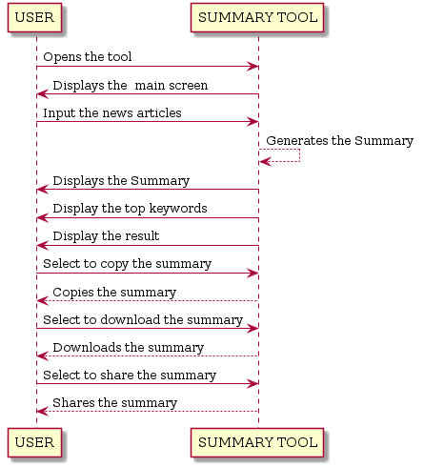

Fig 3.5.2 Sequence Diagram

* 1. **DATA MODELING**

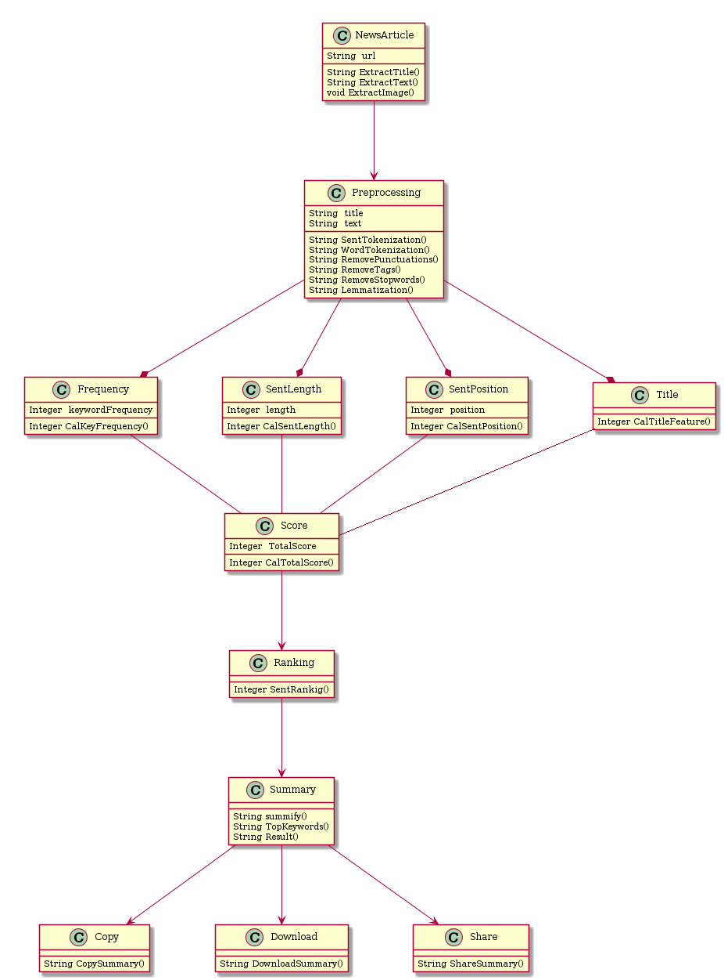

Fig 3.6.1 Class Diagram

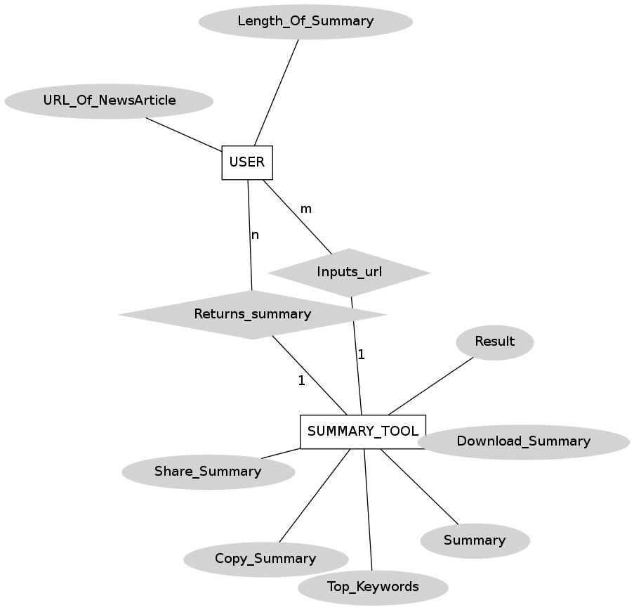

Fig 3.6.2 ER Diagram

* 1. **FUNCTIONAL & BEHAVIOURAL MODELLING**

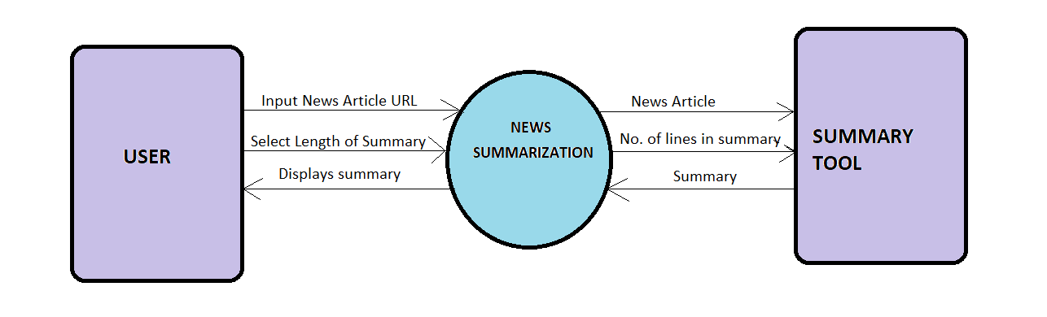

Fig 3.7.1 Context Diagram

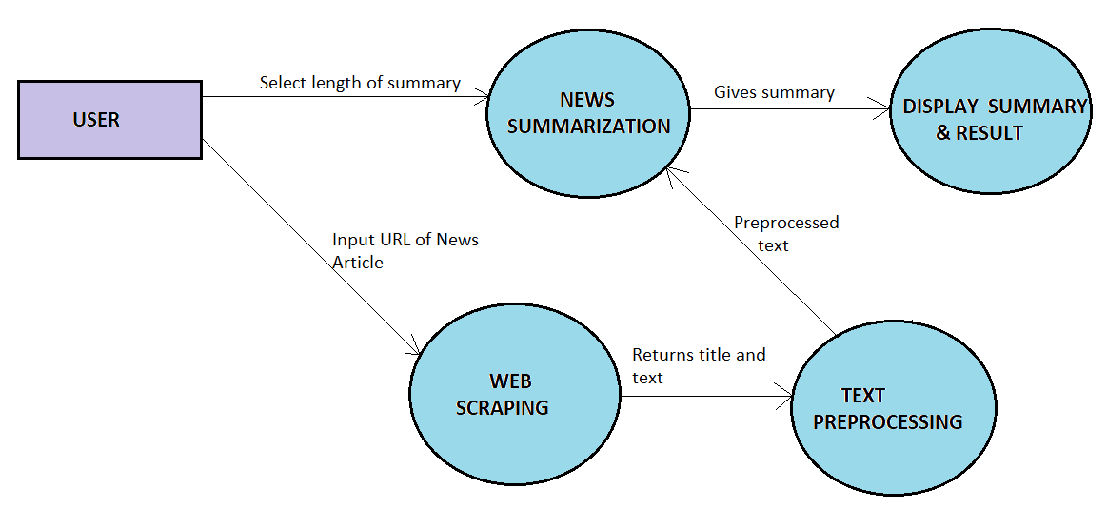

Fig 3.7.2 Data Flow Diagram

* 1. **MAIN MODULE OF NEW SYSTEM**

Here in our application there are mainly 4 modules present. They are as follows :-

* **Module_1: News Article Summarization**

The URL of the news article from various sources like BBC, Reuters, The Guardians, etc. is taken as input. The user has to select the length of summary (i.e range from 4-10 no. of sentences). From the given URL, the content like title, text and image is filtered.

This summarization module consists of four major steps:-

(1) Loading Data

(2) Pre-processing

(3) Feature Extraction

(4) Sentence Scoring and Ranking based on optimized features weight.

In this way, Top ranked sentences are combined to form a summary. Along, with summary top keywords are also generated.

* **Module_2: Text Summarization**

In this module, the text is entered or copied is taken as an input and length of summary is selected. Then text is preprocessed and applied text rank algorithm to generate the summary.

* **Module_3: Webpage Summarization**

In this module, the URL is taken as an input and length of summary is selected.

The text is extracted from URL and preprocessed. Then this preprocessed text is given as an input to text rank algorithm to generate the summary.

* **Module_4: Document Summarization**

In this module, the document in .txt format is selected as an input and length of summary is selected. The text is extracted from the document and preprocessed. Then this preprocessed text is given as an input to text rank algorithm to generate the summary.

* 1. **SELECTION OF HARDWARE & SOFTWARE & JUSTIFICATION**
* **HARDWARE SYSTEM:**
* 32-bit/64-bit Operating System with Internet Connectivity
* **SOFTWARE**
* Python
* Java
* Flask Framework (For Website designing or UI designing)
* Pycharm IDE (Python Programming)
* Android Studio (For Mobile Application Development)

**4. SYSTEM DESIGN**

**4.1 SYSTEM PROCEDURAL DESIGN**

This proposed approach mainly focuses on extractive based summarization method. The objective of extractive summarization is selecting the most relevant sentences of the text. This summarization approach consists of 4 major steps:

1. **Loading Data**

The news is collected from news dataset or using scraping we can collect news data from various news sources then we can apply further processing of summarization.

1. **Preprocessing**

Text need to be preprocessed before processing through the machine. The pre-processing phase contains:-

1. *Tokenization* —Divide the data into sentences and then convert sentences to words
2. Removing unnecessary punctuation, tags.
3. *Removing stop words* — frequent words such as “the”, “is”, etc. that do not have specific semantic.
4. *Lemmatization* — this approach is used to remove inflection by determining the part of speech and utilizing detailed database of the language.
5. **Feature Extraction**

After pre-processing the text, it is split into a collection of sentences. The sentences are ranked based on four important features: Keyword frequency, Sentence Position value, Length of the sentence and Title feature.

1. **Title Score** - determined by calculating every word in each sentence of the article which has similarity with the words in the article title.
2. **Keyword frequency** – Frequency is the number of times a word occurs in a document. Keyword frequency is calculated using two methods i.e DBS and SBS.

Before calculation of keyword frequency using DBS and SBS, the article keywords and the score is determined by finding unique words. Next, keywords and their frequency are ordered from highest weight to the lowest weight. Keyword score can be calculated using:-

KeywordScore($k_{i}$) = (1*|| ÷ |W|)*1.5

Where, $k_{i}$ is the keyword,

|| is the frequency of keywords occurrence in the text,

|W| is the no. of unique keywords in the text.

* 1. ***Density-based Selection (DBS)* –** is used to determine keyword rank in the text based on several parameters. Those parameterd are scored keyword set, words in the sentence that will be calculated, and the words in keyword set. Then the parameters will be calculated by using:-

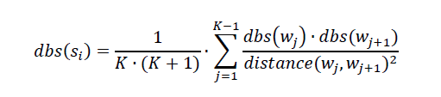

where, $dbs(s_{i}$) is density based selection,

$s_{i}$ top keywords list,

*K* is no of words in sentence,

$dbs(w_{j}$) and $dbs(w_{j+1}$) are weight of keyword $w_{j}$ and $w_{j+1}$ respectively,

$distance(w_{j}$, $w_{j+1}$) is value of two adjacent keyword $w_{j}$ and $w_{j+1}$ and also not a keyword and stopword in .

* 1. ***Summation-based Selection(SBS)****-* is used to determine the sentence weight regarding the occurrence of top keywords in a sentence. The value will be higher if there are more top keywords in a sentence. The weight is calculated by using:-

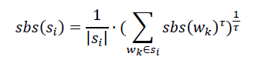

where, $sbs(s_{i}$) is summation-based selection,

$s_{i}$ is a sentence in a text,

${|s}_{i}|$ is the number of words in $s_{i}$, then the parameter to take ( $w_{k})$ word weight which represents the context of text with τ ( τ >0 )

Keyword frequency is obtained as shown in equation:-

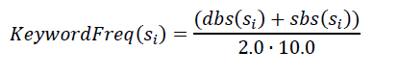

1. **Sentence Position Value** - Position of the sentence in the text, decides its importance. Sentences in the beginning defines the theme of the document whereas end sentences conclude or summarize the document. The positional value of a sentence is computed by assigning the highest score value to the first sentence and the last sentence of the document. Second higher score value to the second sentence from starting and second last sentence of the document. Remaining sentences are assigned score value zero.
2. **Sentence Length Score**- obtained by counting the number of words in a sentence.
3. **Sentence Scoring and Ranking based on optimized features weight**

The final score is a Combination of keyword frequency, Sentence positional value, Sentemce length score and title score. After scoring of each sentence, sentences are arranged in descending order of their score value i.e. the sentence whose score value is highest is in top position and the sentence whose score value is lowest is in bottom position.

In this way by combining various extractive features we have generated summary of an given url of news article with top keywords.

**4.2 STATE TRANSITION DIAGRAM**

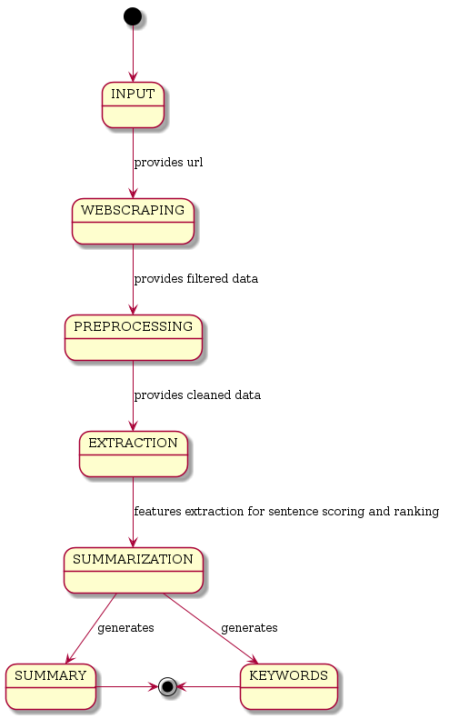

Fig 4.2 State Transition Diagram

**5. IMPLEMENTATION PLANNING AND DETAILS**

We have developed Web Application as well as Android Application for the summarization of news article. We have used various types of technologies to make the application productive. The main purpose is to provide reliable summaries of web pages or uploaded files depends on the user’s choice. The unnecessary sentences will be discarded to obtain the most important sentences.

**5.1 IMPLEMENTATION ENVIRONMENT**

1. **WEB APPLICATION**

The Following technologies are used in developing the web app:

1. **Python 3:** It is used for coding the algorithm of proposed summarization. As python is an interpreted, object-oriented, high-level programming language with dynamic semantics. It supports modules and packages and its simple and easy to learn.
2. **Pycharm IDE:** It is an Integrated Developed environment used in computer programming, specifically python language. It provides code analysis, a graphical debugger, an integrated unit tester and supports web development with Django and flask. It is cross-platform with Windows, macOS and Linux versions.
3. **Flask Framework:** Flask is a lightweight WSGI web application framework. It is designed to make getting started quick and easy, with the ability to scale up to complex applications. It began as a simple wrapper around Werkzeug and Jinja and has become one of the most popular Python web application frameworks. Flask offers suggestions, but doesn't enforce any dependencies or project layout. It is up to the developer to choose the tools and libraries they want to use. There are many extensions provided by the community that make adding new functionality easy.
4. **HTML:** HyperText Markup Language(HTML) is the most basic building block of the Web. It defines the meaning and structure of web content. "Hypertext" refers to links that connect web pages to one another, either within a single website or between websites. Links are a fundamental aspect of the Web. By uploading content to the Internet and linking it to pages created by other people, you become an active participant in the World Wide Web.
5. **CSS:** Stands for "Cascading Style Sheet." Cascading style sheets are used to format the layout of Web pages. They can be used to define text styles, table sizes, and other aspects of Web pages that previously could only be defined in a page's HTML.
6. **BOOTSTRAP:** It is one of the most popular web development frameworks out there, and it is used for developing highly-responsive projects in HTML, CSS, and JavaScript. Essentially, what Bootstrap does is reduce the time needed to get a modern website up and running.
7. **JAVASCRIPT:** JavaScript is a dynamic computer programming language. It is lightweight and most commonly used as a part of web pages, whose implementations allow client-side script to interact with the user and make dynamic pages. It is an interpreted programming language with object-oriented capabilities.
8. **NLTK:** Nltk is natural language toolkit library. It is a platform for building Python programs to work with human languages. It provides easy-to-use interfaces to over 50 corpora and lexical resources such as WordNet, along with a suite of text processing libraries for classification, tokenization, stemming, tagging, parsing, and semantic reasoning, wrappers for industrial-strength NLP libraries, and an active discussion forum. In text summarizer, this library is used to remove stop words in English vocabulary and to convert these words to root forms.
9. **Newspaper Library:** Newspaper is a Python module used for extracting and parsing newspaper articles. Newspaper use advance algorithms with web scrapping to extract all the useful text from a website. It works amazingly well on online newspapers websites. Since it use web scrapping too many request to a newspaper website may lead to blocking, so use it accordingly.
10. **ANDROID APPLICATION**

The Following technologies are used in developing the android app:

1. **Java:** It is used for coding the algorithm of proposed summarization.
2. **Android Studio:** Android Studio is the official IDE for android application development. It works based on IntelliJ IDEA.
3. **Jsoup:** It is a Java library for working with real-world HTML. It provides a very convenient API for fetching URLs and extracting and manipulating data, using the best of HTML5 DOM methods and CSS selectors.
4. **Apache OpenNLP:** This library is a machine learning based toolkit for the processing of natural language text.
5. **Android Sliding Up Panel:** This library provides a simple way to add a draggable sliding up panel (popularized by Google Music and Google Maps) to your Android application.

**6. TESTING**

## **Software testing** is a process, to evaluate the functionality of a software application with an intent to find whether the developed software met the specified requirements or not and to identify the defects to ensure that the product is defect-free in order to produce the quality product.

## According to **ANSI/IEEE 1059**standard – A process of analyzing a software item to detect the differences between existing and required conditions (i.e., defects) and to evaluate the features of the software item.

### **Principles of Testing:-**

* All the test should meet the customer requirements.
* To make our software testing should be performed by third party  
  Exhaustive testing is not possible.
* As we need the optimal amount of testing based on the risk assessment of the application.
* All the test to be conducted should be planned before implementing it
* It follows pareto rule(80/20 rule) which states that 80% of errors comes from 20% of program components.
* Start testing with small parts and extend it to large parts.

**6.1 TESTING PLANNING**

## **Software Testing Types:**

## **Manual Testing:**Manual testing is the process of testing software by hand to learn more about it, to find what is and isn’t working. This usually includes verifying all the features specified in requirements documents, but often also includes the testers trying the software with the perspective of their end user’s in mind. Manual test plans vary from fully scripted test cases, giving testers detailed steps and expected results, through to high-level guides that steer exploratory testing sessions.

## **Automation Testing:**Automation testing is the process of testing the software using an automation tool to find the defects. In this process, testers execute the test scripts and generate the test results automatically by using automation tools. Some of the famous automation testing tools for functional testing are QTP/UFT and Selenium.

**6.2 TESTING STRATEGY**

1. **Unit Testing:** Unit Testing is done to check whether the individual modules of the source code are working properly. i.e. testing each and every unit of the application separately by the developer in the developer’s environment. It is also known as Module Testing or Component Testing.
2. **Integration Testing:** Integration Testing is the process of testing the connectivity or data transfer between a couple of unit tested modules. It is also known as I&T Testing or String Testing. It is subdivided into the Top-Down Approach, Bottom-Up Approach, and Sandwich Approach (Combination of Top-Down and Bottom-Up).
3. **System Testing (End to End Testing):** It’s a black box testing. Testing the fully integrated application this is also called as an end to end scenario testing. To ensure that the software works in all intended target systems. Verify thorough testing of every input in the application to check for desired outputs. Testing of the user’s experiences with the application.
4. **Acceptance Testing:** To obtain customer sign-off so that software can be delivered and payments received. Types of Acceptance Testing are Alpha, Beta & Gamma Testing.

**6.3 TESTING METHODS**

1. **White Box Testing:**It is also called as Glass Box, Clear Box, Structural Testing. White Box Testing is based on application’s internal code structure. In white-box testing, an internal perspective of the system, as well as programming skills, are used to design test cases. This testing is usually done at the unit level.
2. **Black Box Testing:**It is also called as Behavioral/Specification-Based/Input-Output Testing. Black Box Testing is a software testing method in which testers evaluate the functionality of the software under test without looking at the internal code structure.
3. **Grey Box Testing:**Grey box is the combination of both White Box and Black Box Testing. The tester who works on this type of testing needs to have access to design documents. This helps to create better test cases in this process.

**6.4 TEST CASES**

## **Test case** - is the smallest unit of the testing plan - which includes a description of necessary actions and parameters to achieve and verify the expected behaviour of a particular function or the part of the tested software.

## If you have a task to check some functionality, you can create a test script or user story. So you need to understand where to start testing, which general steps need to be executed and what the result should be. And then this scenario is broken down into more detailed parts – test cases – to define all positive, negative, localisation and other behaviours of the software.

## **Types of test cases**

In order to efficiently cover the functional by tests, test cases need to be divided into types. If you start doing it, then their number will increase at least in three times. Various sources describe types in different ways, but the essence of the division does not change. We offer the following types of test cases that should divide your test plan:

### **Positive -**There are test cases aimed at checking the correct operation of the claimed functionality using the correct input format specified in the software documentation.

1. **Negative -** There are test cases that check your anticipated every possible situation that should lead to an error message. Also, this type of test cases includes a verification that can lead to unexpected situations, ie those that are not described in the documentation. For example, you can test the field email, introducing the characters that are not included in the list mentioned above. You can also try to interrupt the fields, check whether the data is stored in the system reboot or exposure to other external factors.
2. **Boundary Value -** To check the values on either side constraints. One of these relates to tests positive, the other to negative. It is better to isolate them not to miss.
3. **Testing localisation -** Check all UI elements in different languages and their locations (if there is a support for languages with different rules of writing and reading).  
   For example, if your software supports one of the location where the UI is placed from the right to left, you should pay attention to the work of Drop-Down List, check boxes, switching elements On / Off, etc.

**TEST CASE_1**

|  |  |
| --- | --- |
| **Test Case ID:** SUMMARY_1 | **Test Designed by:** ANIKET |
| **Test Priority (Low/Medium/High):** HIGH | **Test Designed date:** 24/03/20 |
| **Test Title:** VALID (EN) TEXT DATA IS COPY AND PASTED | **Test Executed by:** SHASTRI |
| **Description:** TEST WEBSITE TEXT SUMMARY GENERATOR | **Test Execution date:** 29/03/20 |

|  |
| --- |
| **Pre-conditions:**  USER MUST HAVE DATA THAT HE/SHE NEEDS TO GET SUMMARY FOR |

|  |  |  |  |  |  |
| --- | --- | --- | --- | --- | --- |
| **No** | **Test Steps** | **Test Data** | **Expected Result** | **Actual Result** | **Status**  **(Pass/Fail)** |
| 1 | NAVIGATE TO TEXT SUMMARIZATION PAGE | USER’S TEXT DATA | SUMMARY FOR GIVEN INPUT DATA | SUMMARY WITH COMPRESSION RATE (IN %) IS DISPLAYED ON SCREEN | PASS |
| 2 | COPY PASTE TEXT DATA |
| 3 | SELECT LENGTH OF SUMMARY |
| 4 | CLICK SUMMIFY BUTTON |

|  |
| --- |
| **Post-conditions:**  RESULT MUST BE COPIED OR DOWNLOADED BY THE USER |

**TEST CASE_2**

|  |  |
| --- | --- |
| **Test Case ID:** SUMMARY_2 | **Test Designed by:** ANIKET |
| **Test Priority (Low/Medium/High):** HIGH | **Test Designed date:** 24/03/20 |
| **Test Title:** NO DATA ENTERED OR COPY PASTED | **Test Executed by:** SHASTRI |
| **Description:** TEST WEBSITE TEXT SUMMARY GENERATOR | **Test Execution date:** 29/03/20 |

|  |
| --- |
| **Pre-conditions:**  USER MUST HAVE DATA THAT HE/SHE NEEDS TO GET SUMMARY FOR |

|  |  |  |  |  |  |
| --- | --- | --- | --- | --- | --- |
| **No** | **Test Steps** | **Test Data** | **Expected Result** | **Actual Result** | **Status**  **(Pass/Fail)** |
| 1 | NAVIGATE TO TEXT SUMMARIZATION PAGE | USER’S TEXT DATA | ALERT MESSAGE TO BE DISPLAYED | MESSAGE SHOWN IS  “PLEASE ENTER TEXT DATA OF MIN 100 WORDS” | PASS |
| 2 | ENTERED NO DATA |
| 3 | SELECT LENGTH OF SUMMARY |
| 3 | CLICK SUMMYFY! BUTTON |

|  |
| --- |
| **Post-conditions:**  N.A |

**TEST CASE_3**

|  |  |
| --- | --- |
| **Test Case ID:** SUMMARY_3 | **Test Designed by:** ANIKET |
| **Test Priority (Low/Medium/High):** HIGH | **Test Designed date:** 24/03/20 |
| **Test Title:** SUMMARY LENGTH NOT SELECTED | **Test Executed by:** SHASTRI |
| **Description:** TEST WEBSITE TEXT SUMMARY GENERATOR | **Test Execution date:** 29/03/20 |

|  |
| --- |
| **Pre-conditions:**  TEXT DATA SHOULD BE ENTERED |

|  |  |  |  |  |  |
| --- | --- | --- | --- | --- | --- |
| **No** | **Test Steps** | **Test Data** | **Expected Result** | **Actual Result** | **Status**  **(Pass/Fail)** |
| 1 | NAVIGATE TO TEXT SUMMARIZATION PAGE | NOT SELECTED LENGTH | NO ALERT MESSAGE TO BE DISPLAYED | SUMMARY WITH 5 SENTENCES SHOULD BE GENERATED | PASS |
| 2 | CLICK SUMMIFY BUTTON |

|  |
| --- |
| **Post-conditions:**  N.A |

**TEST CASE_4**

|  |  |
| --- | --- |
| **Test Case ID:** URL_1 | **Test Designed by:** ANIKET |
| **Test Priority (Low/Medium/High):** MED | **Test Designed date:** 06/04/20 |
| **Test Title:** WIKIPEDIA URL ENTERED | **Test Executed by:** RAJU |
| **Description:** TEST WEBSITE WEB PAGE SUMMARY PAGE | **Test Execution date:** 12/04/20 |

|  |
| --- |
| **Pre-conditions:**  URL OF WEB PAGE IS REQUIRED |

|  |  |  |  |  |  |
| --- | --- | --- | --- | --- | --- |
| **No** | **Test Steps** | **Test Data** | **Expected Result** | **Actual Result** | **Status**  **(Pass/Fail)** |
| 1 | NAVIGATE TO URL PAGE | URL=<https://en.wikipedia.org/wiki/Machine_learning> | SUMMARY SHOULD BE GENERATED | SUMMARY GENERATED | PASS |
| 2 | ENTER URL |
| 3 | SELECT LENGTH OF SUMMARY |
| 4 | CLICK LOGIN BUTTON |

|  |
| --- |
| **Post-conditions:**  CAN COPY OR DOWNLOAD THE SUMMARY |

**TEST CASE_5**

|  |  |
| --- | --- |
| **Test Case ID:** URL_2 | **Test Designed by:** ANIKET |
| **Test Priority (Low/Medium/High):** MED | **Test Designed date:** 06/04/20 |
| **Test Title:** ENTERED URL OF TIMES OF INDIA ARTICLE | **Test Executed by:** RAJU |
| **Description:** TEST WEBSITE WEB PAGE SUMMARIZATION PAGE | **Test Execution date:** 12/04/20 |

|  |
| --- |
| **Pre-conditions:**  URL OF WEB PAGE IS REQUIRED |

|  |  |  |  |  |  |
| --- | --- | --- | --- | --- | --- |
| **No** | **Test Steps** | **Test Data** | **Expected Result** | **Actual Result** | **Status**  **(Pass/Fail)** |
| 1 | NAVIGATE TO WEB PAGE SUMMARIZATION PAGE | <https://timesofindia.indiatimes.com/> | SUMMARY SHOULD BE DISPLAYED | ERROR MESSAGE IS SHOWN | FAIL |
| 2 | ENTER URL |
| 3 | SELECT LENGTH OF SUMMARY |
| 4 | CLICK SUMMIFY BUTTON |

|  |
| --- |
| **Post-conditions:**  N.A |

**TEST CASE_6**

|  |  |
| --- | --- |
| **Test Case ID:** DOC_1 | **Test Designed by:** UPASANA |
| **Test Priority (Low/Medium/High):** MED | **Test Designed date:** 08/04/20 |
| **Test Title:** SELECTED TXT FILE | **Test Executed by:** TUSHAR |
| **Description:** TEST WEBSITE DOCUMENT SUMMARIZATION PAGE | **Test Execution date:** 14/04/20 |

|  |
| --- |
| **Pre-conditions:**  TEXT FILE IS REQUIRED |

|  |  |  |  |  |  |
| --- | --- | --- | --- | --- | --- |
| **No** | **Test Steps** | **Test Data** | **Expected Result** | **Actual Result** | **Status**  **(Pass/Fail)** |
| 1 | NAVIGATE TO DOCUMENT SUMMARIZATION PAGE | DOCNAME=demo.txt | SUMMARY WITH RESULT | SUMMARY WITH RESULT | PASS |
| 2 | SELECT THE DOCUMENT |
| 3 | SELECT THE LENGTH |
| 3 | CLICK ON SUMMIFY BUTTON |

|  |
| --- |
| **Post-conditions:**  N.A. |

**TEST CASE_7**

|  |  |
| --- | --- |
| **Test Case ID:** DOC_2 | **Test Designed by:** UPASANA |
| **Test Priority (Low/Medium/High):** MED | **Test Designed date:** 08/04/20 |
| **Test Title:** SELECTED DOC FILE AS AN INPUT | **Test Executed by:** TUSHAR |
| **Description:** TEST WEBSITE DOCUMENT SUMMARIZATION PAGE | **Test Execution date:** 14/04/20 |

|  |
| --- |
| **Pre-conditions:**  TEXT FILE IS REQUIRED |

|  |  |  |  |  |  |
| --- | --- | --- | --- | --- | --- |
| **No** | **Test Steps** | **Test Data** | **Expected Result** | **Actual Result** | **Status**  **(Pass/Fail)** |
| 1 | NAVIGATE TO DOCUMENT SUMMARIZATION PAGE | DOCNAME=demo.doc | ERROR MESSAGE TO BE GENERATED | ERROR MESSAGE  GENERATED  “PLEASE SCELECT TXT FILE ONLY” | PASS |
| 2 | BROWSE FOR THE DOCUMENT |
| 4 | SELECT LENGTH OF SUMMARY |
| 3 | CLICK SENT LINK BUTTON |

|  |
| --- |
| **Post-conditions:**  N.A |

**TEST CASE_8**

|  |  |
| --- | --- |
| **Test Case ID:** NEWS ARTICLE_1 | **Test Designed by:** UPASANA |
| **Test Priority (Low/Medium/High):** HIGH | **Test Designed date:** 20/04/20 |
| **Test Title:** URL OF REUTERS ARTICLE | **Test Executed by:** REEMA |
| **Description:** TEST WEBSITE NEWS ARTICLE SUMMARIZATION | **Test Execution date:** 24/04/20 |

|  |
| --- |
| **Pre-conditions:**  GOOD INTERNET BANDWIDTH AND URL OF NEWS ARTICLE |

|  |  |  |  |  |  |
| --- | --- | --- | --- | --- | --- |
| **No** | **Test Steps** | **Test Data** | **Expected Result** | **Actual Result** | **Status**  **(Pass/Fail)** |
| 1 | NAVIGATE TO NEWS ARTICLE TEXT SUMMARIZATION PAGE | URL OF REUTERS NEWS ARTICLE | SUMMARY WITH KEYWORDS AND RESULT | SUMMARY WITH KEYWORDS AND RESULT | PASS |
| 2 | ENTER URL OF NEWS ARTICLE |
| 3 | SELECT LENGTH OF SUMMARY |
| 2 | CLICK ON SUMMIFY |

|  |
| --- |
| **Post-conditions:**  N.A |

**TEST CASE_9**

|  |  |
| --- | --- |
| **Test Case ID:** NEWS ARTICLE_2 | **Test Designed by:** UPASANA |
| **Test Priority (Low/Medium/High):** HIGH | **Test Designed date:** 20/04/20 |
| **Test Title:** URL OF CNN HOME PAGE | **Test Executed by:** REEMA |
| **Description:** TEST WEBSITE NEWS ARTICLE SUMMARIZATION | **Test Execution date:** 24/04/20 |

|  |
| --- |
| **Pre-conditions:**  URL OF NEWS WEBSITE IS REQUIRED |

|  |  |  |  |  |  |
| --- | --- | --- | --- | --- | --- |
| **No** | **Test Steps** | **Test Data** | **Expected Result** | **Actual Result** | **Status**  **(Pass/Fail)** |
| 1 | NAVIGATE TO NEWS ARTICLE SUMMARIZATION PAGE | URL OF CNN HOME PAGE | ERROR PAGE | ERROR PAGE WITH MESSAGE  “PLEASE ENTER URL OF NEWS ARTICLE ONLY” | PASS |
| 2 | ENTER URL OF NEWS ARTICLE |
| 3 | SELECT LENGTH OF SUMMARY |
| 4 | CLICK ON SUMMIFY |

|  |
| --- |
| **Post-conditions:**  ENTER URL OF NEWS ARTICLE ONLY. |

**TEST CASE_10**

|  |  |
| --- | --- |
| **Test Case ID:** CONTACT-US_1 | **Test Designed by:** UPASANA |
| **Test Priority (Low/Medium/High):** LOW | **Test Designed date:** 01/05/20 |
| **Test Title:** CONTACT US FORM | **Test Executed by:** AYUSHMAN |
| **Description:** TEST WEBSITE CONTACT US PAGE | **Test Execution date:** 05/05/20 |

|  |
| --- |
| **Pre-conditions:**  ANY ISSUES OR COMPLAIN |

|  |  |  |  |  |  |
| --- | --- | --- | --- | --- | --- |
| **No** | **Test Steps** | **Test Data** | **Expected Result** | **Actual Result** | **Status**  **(Pass/Fail)** |
| 1 | NAVIGATE TO CONTACT US PAGE | EMAIL-ID=XYZ@ABC.COM  ENTER SUBJECT AND MESSAGE | SUBMITTED MESSAGE DISPLAYED | “MESSAGE SENT.  OUR REPRESENTATIVE WILL COME IN TOUCH WITH YOU”  SHOULD BE DISPLAYED | PASS |
| 2 | ENTER EMAIL-ID |
| 3 | TYPE SUBJECT |
| 4 | TYPE MESSAGE DETAILS |
| 5 | CLICK SEND BUTTON |

|  |
| --- |
| **Post-conditions:**  MESSAGE MUST BE SUBMITTED TO COMPANY’S MAIL-ID |

**TEST CASE_11**

|  |  |
| --- | --- |
| **Test Case ID:** CONTACT-US_2 | **Test Designed by:** UPASANA |
| **Test Priority (Low/Medium/High):** LOW | **Test Designed date:** 01/05/20 |
| **Test Title:** EMPTYCONTACT US FORM | **Test Executed by:** AYUSHMAN |
| **Description:** TEST WEBSITE CONTACT US PAGE | **Test Execution date:** 05/05/20 |

|  |
| --- |
| **Pre-conditions:**  ANY QUERY OR COMPLAIN |

|  |  |  |  |  |  |
| --- | --- | --- | --- | --- | --- |
| **No** | **Test Steps** | **Test Data** | **Expected Result** | **Actual Result** | **Status**  **(Pass/Fail)** |
| 1 | NAVIGATE TO CONTACT US PAGE | ONLY  EMAIL-ID=XYZ@ABC.COM  ENTERED | ERROR MESSAGE DISPLAYED | “PLEASE ENTER SUBJECT AND MESSAGE DETAILS”  SHOULD BE DISPLAYED | PASS |
| 2 | ENTER EMAIL-ID |
| 3 | CLICK MESSAGE BUTTON |

|  |
| --- |
| **Post-conditions:**  N.A |

**7. SCREENSHOTS AND USER MANUAL**

**7.1 WEB APPLICATION (SUMMIFY)**

(1) **Home Page**

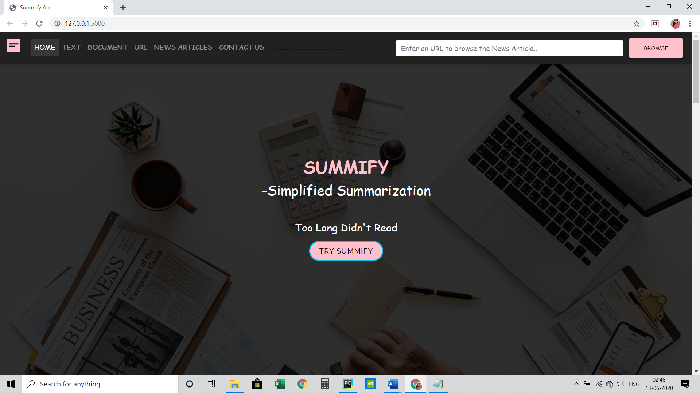

1. **Text Summarization Page:**
2. Click on “Text” from Nav Bar at the top of the page.

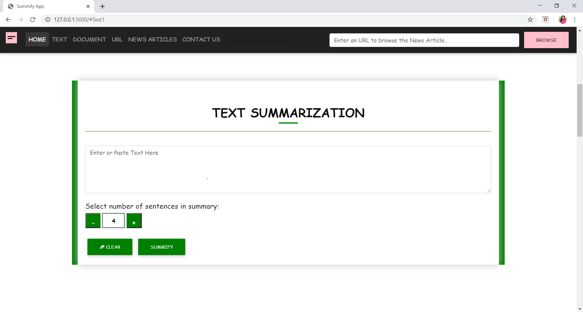

1. Enter or copy text input.
2. Select Length of the summary.
3. Click on “SUMMIFY”.
4. Select “CLEAR” to erase all the fields previously entered.

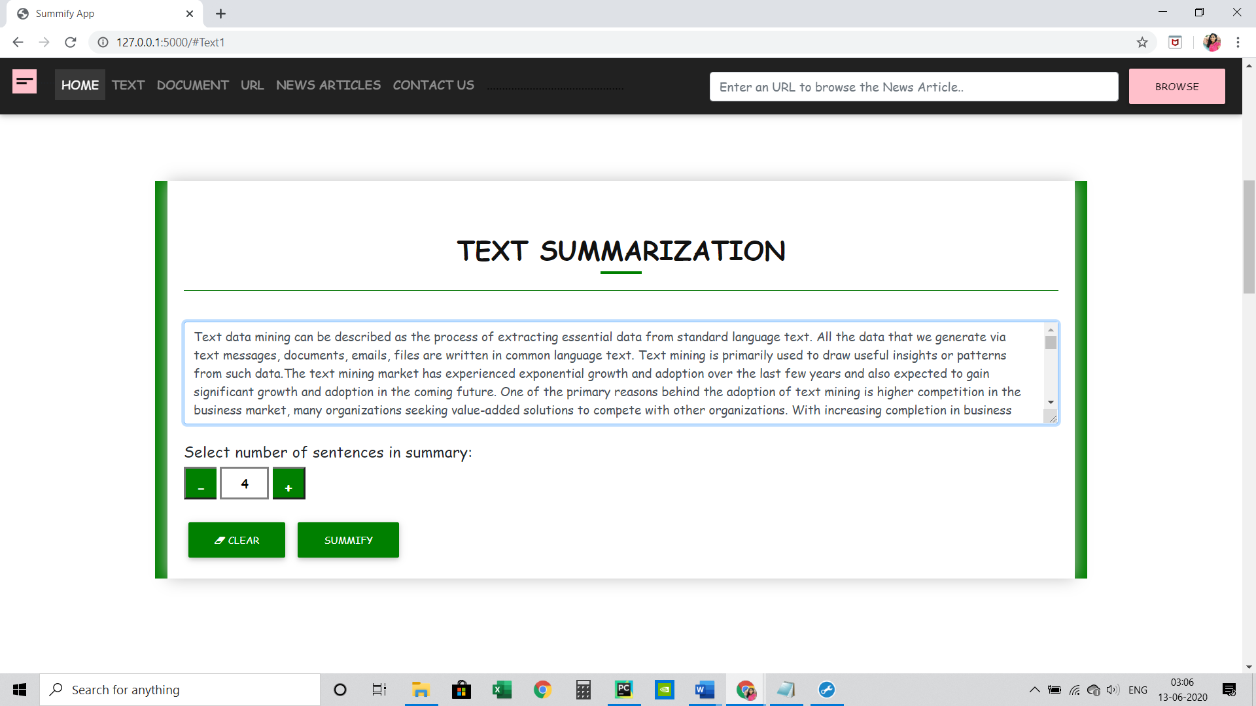

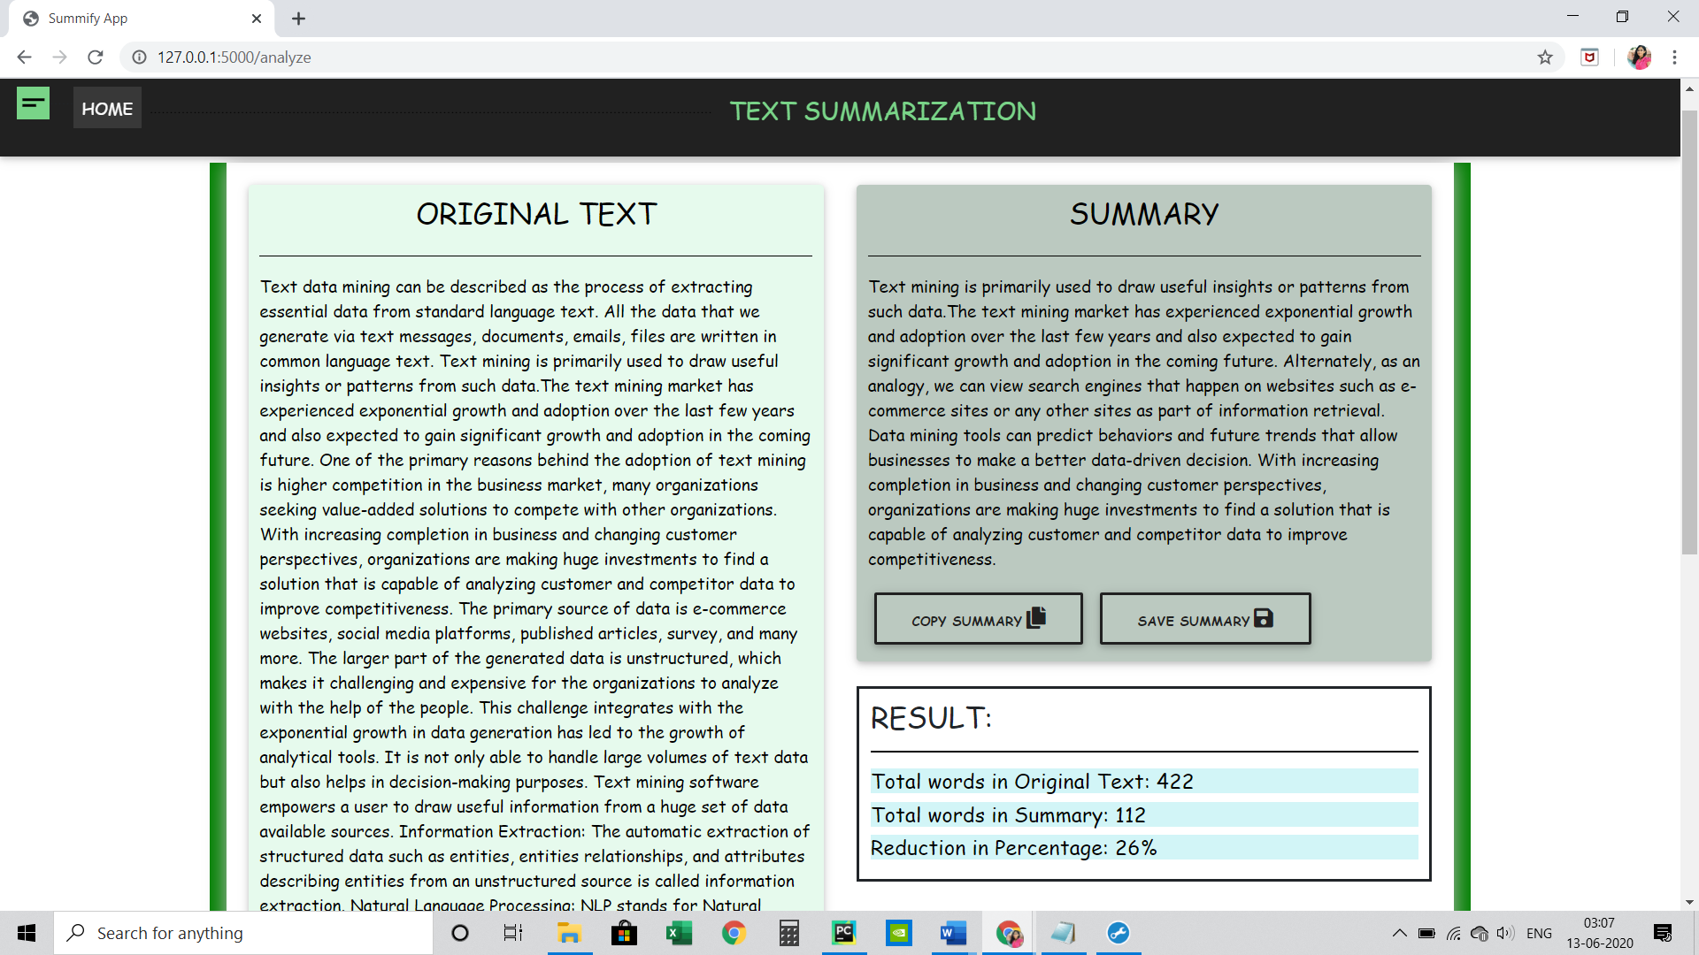 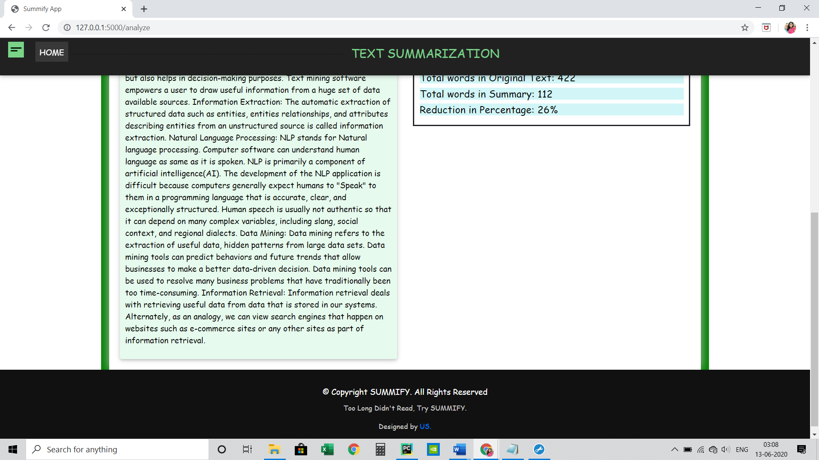

1. **Document Summarization Page:**
   1. Click on “Document” from Nav Bar at the top of the page.

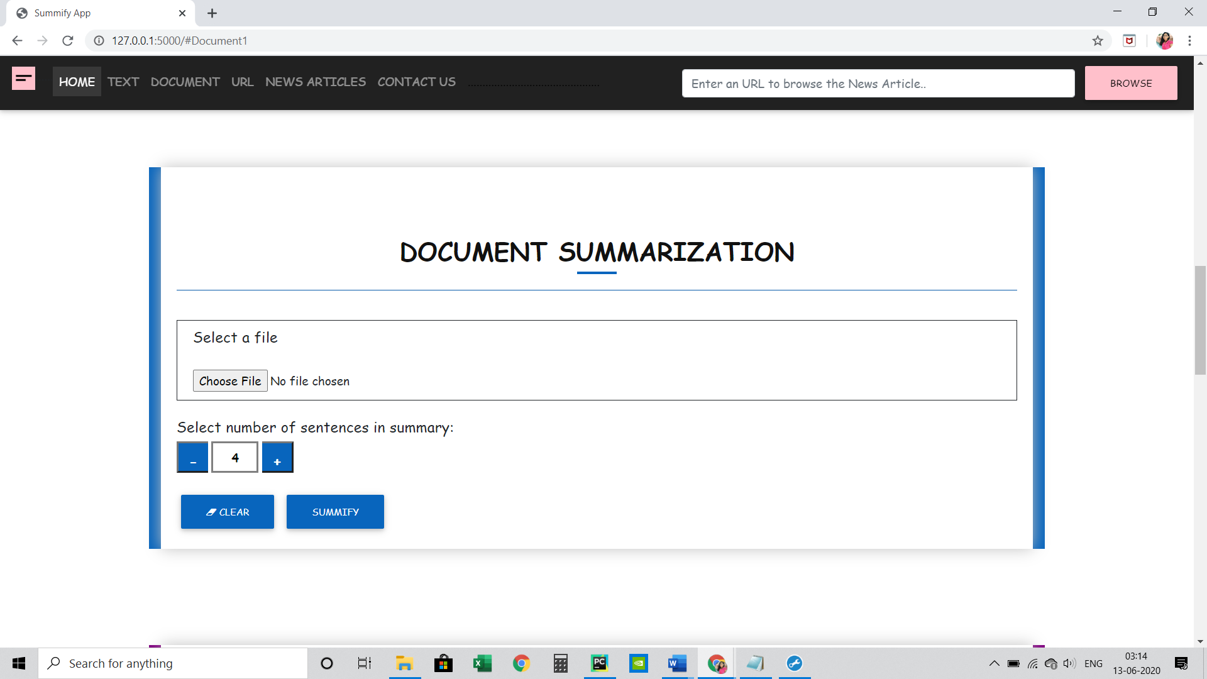

* 1. Browse the file in .txt format and select for the input.
  2. Select Length of the summary.
  3. Click on “SUMMIFY”.
  4. Select “CLEAR” to erase all the fields previously entered.

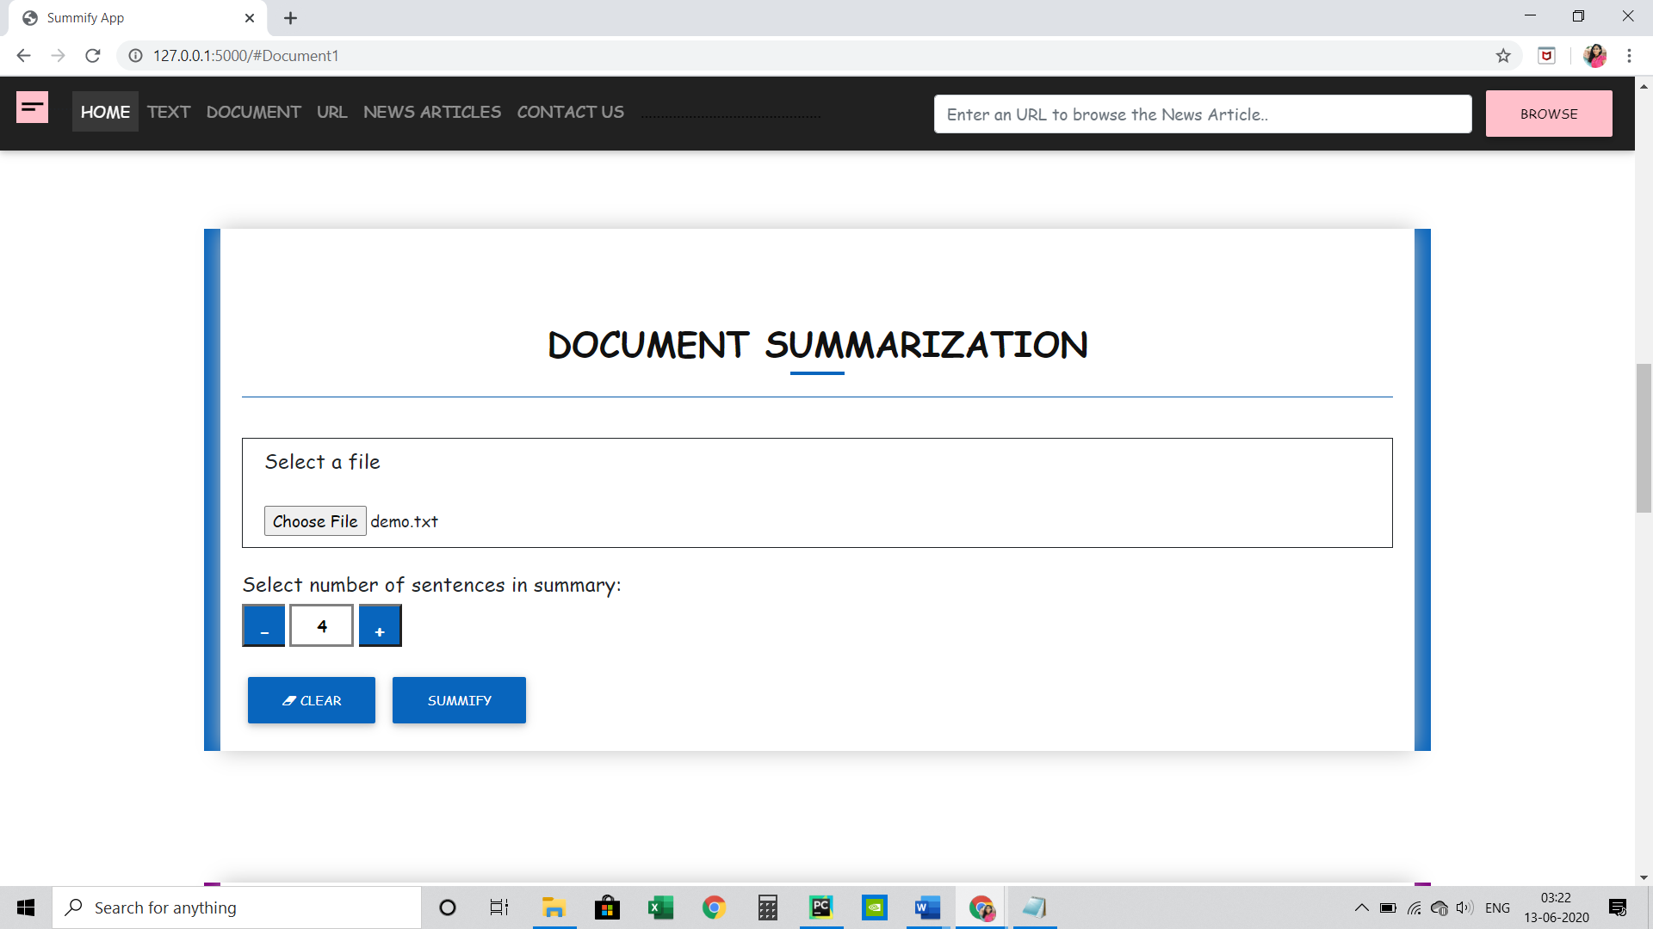

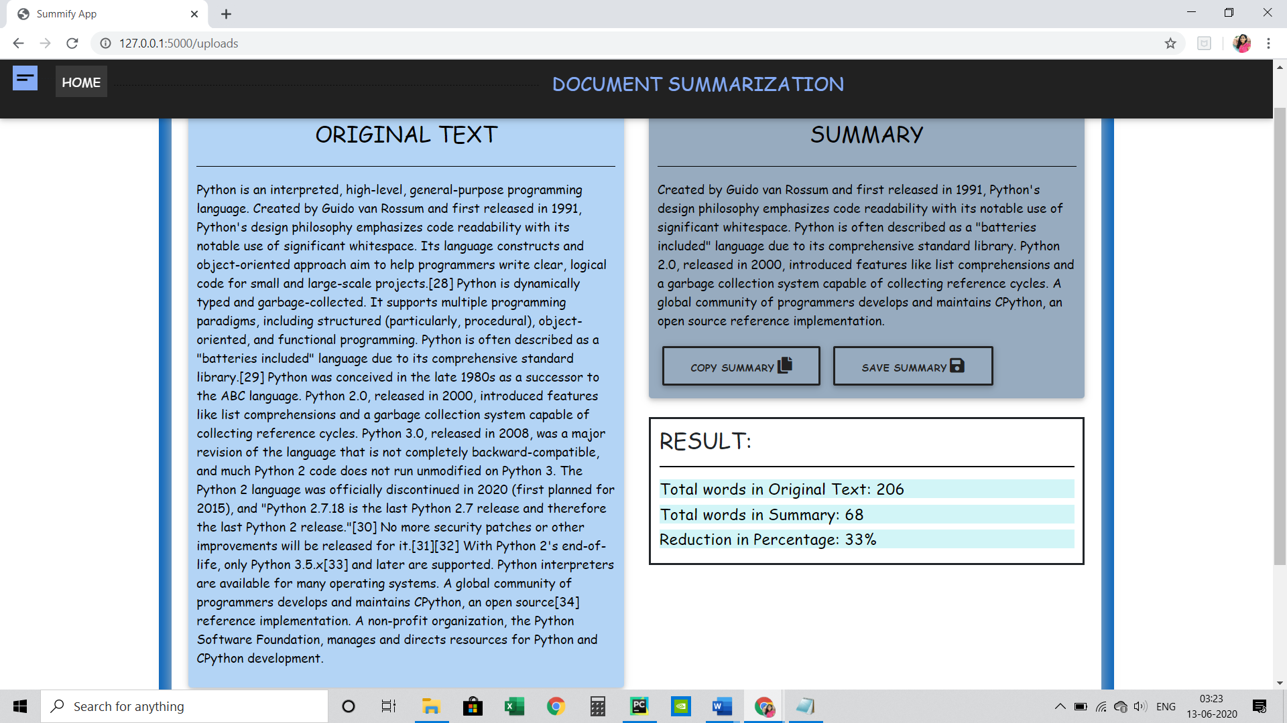

1. **Webpage Summarization:**
   1. Click on “URL” from Nav Bar at the top of the page.

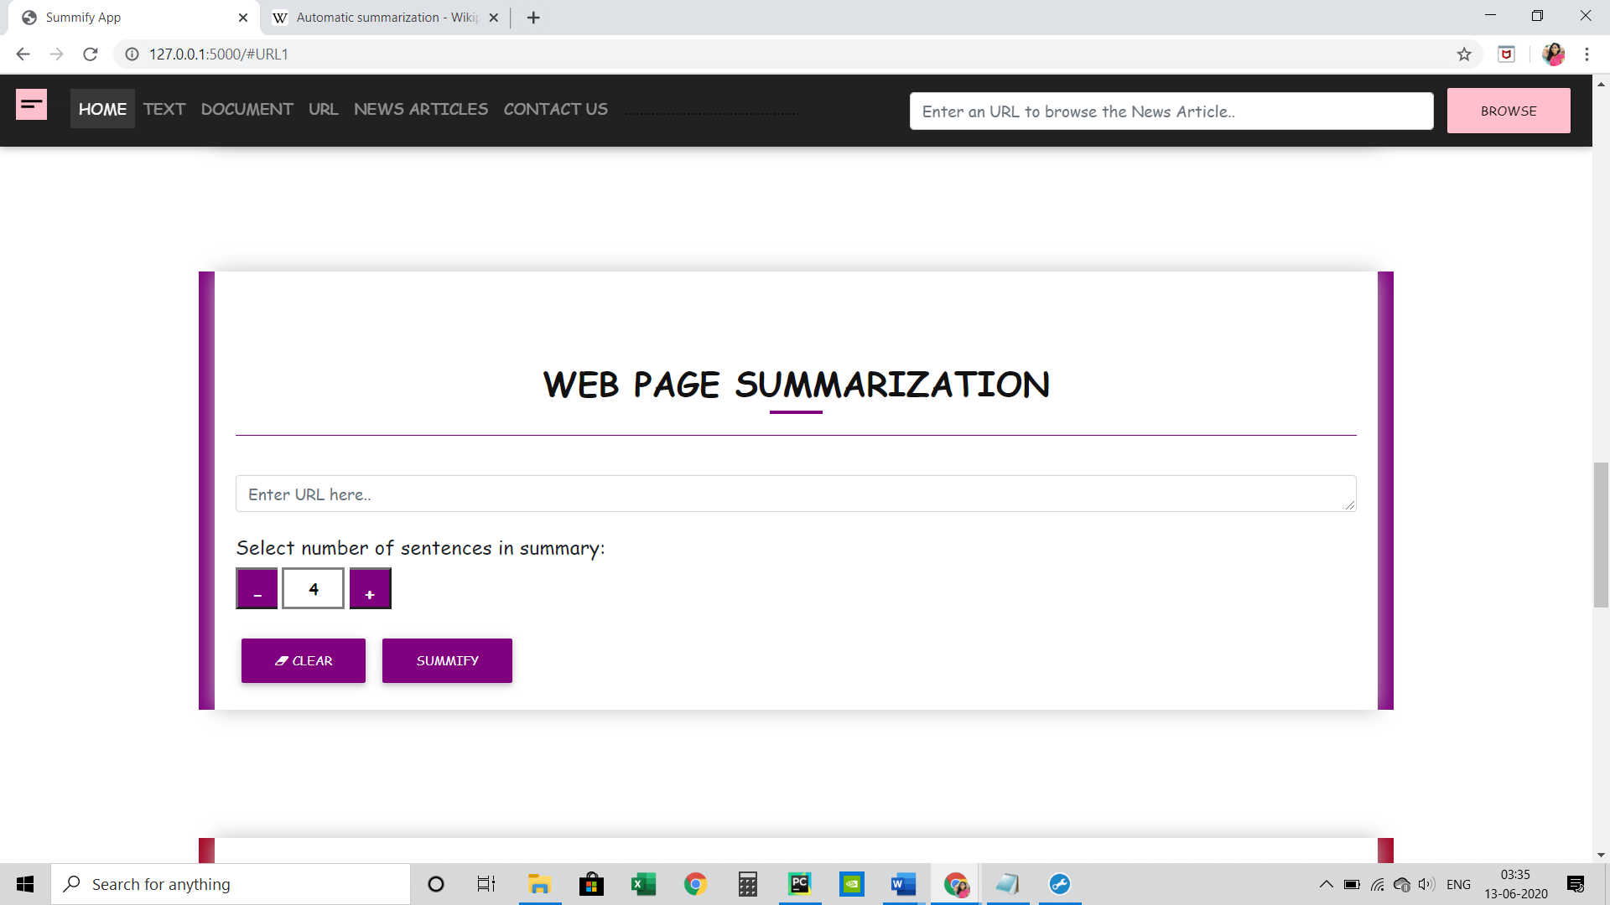

* 1. Entered the URL of the webpage to want to summarize.
  2. Select Length of the summary.
  3. Click on “SUMMIFY”.
  4. Select “CLEAR” to erase all the fields previously entered.

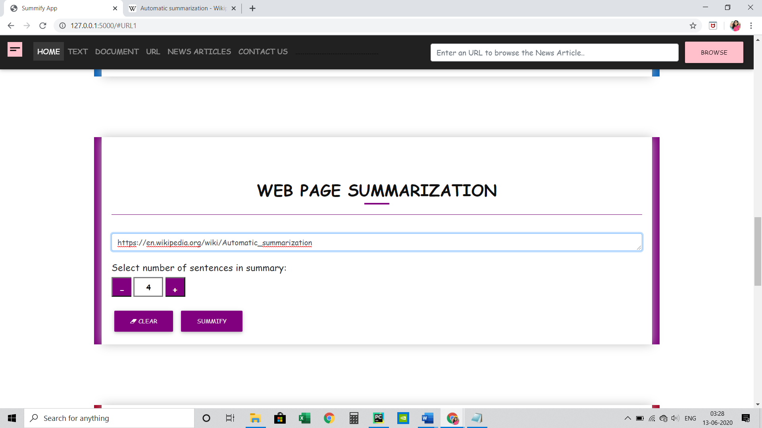

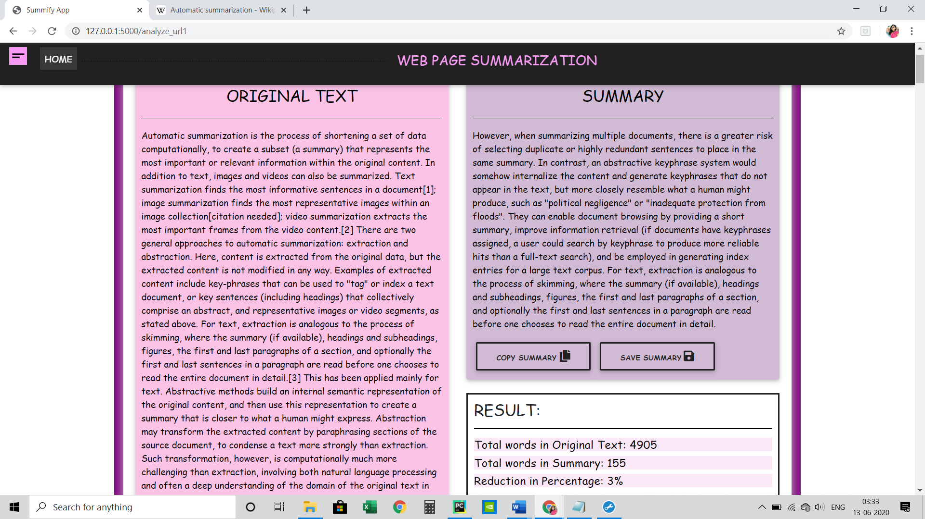

1. **News Article Summarization:**
2. Click on “News Article” from Nav Bar at the top of the page.

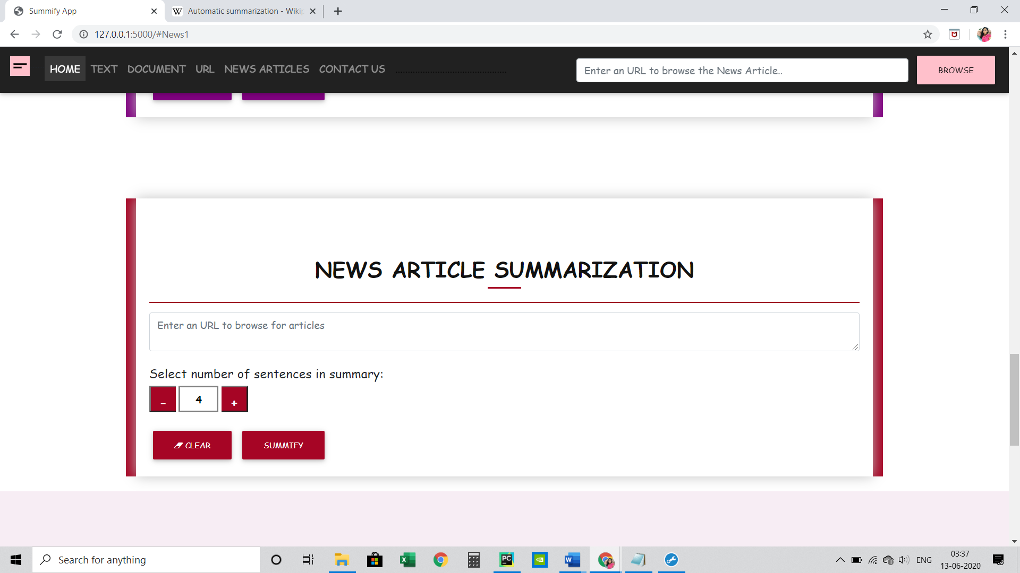

1. Enter the URL of the News Article page.
2. Select Length of the summary.
3. Click on “SUMMIFY”.
4. Select “CLEAR” to erase all the fields previously entered.

**BBC NEWS ARTICLE**

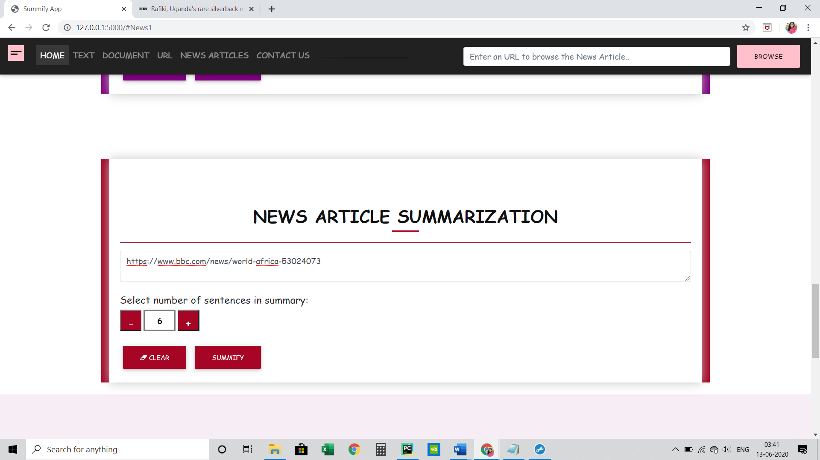

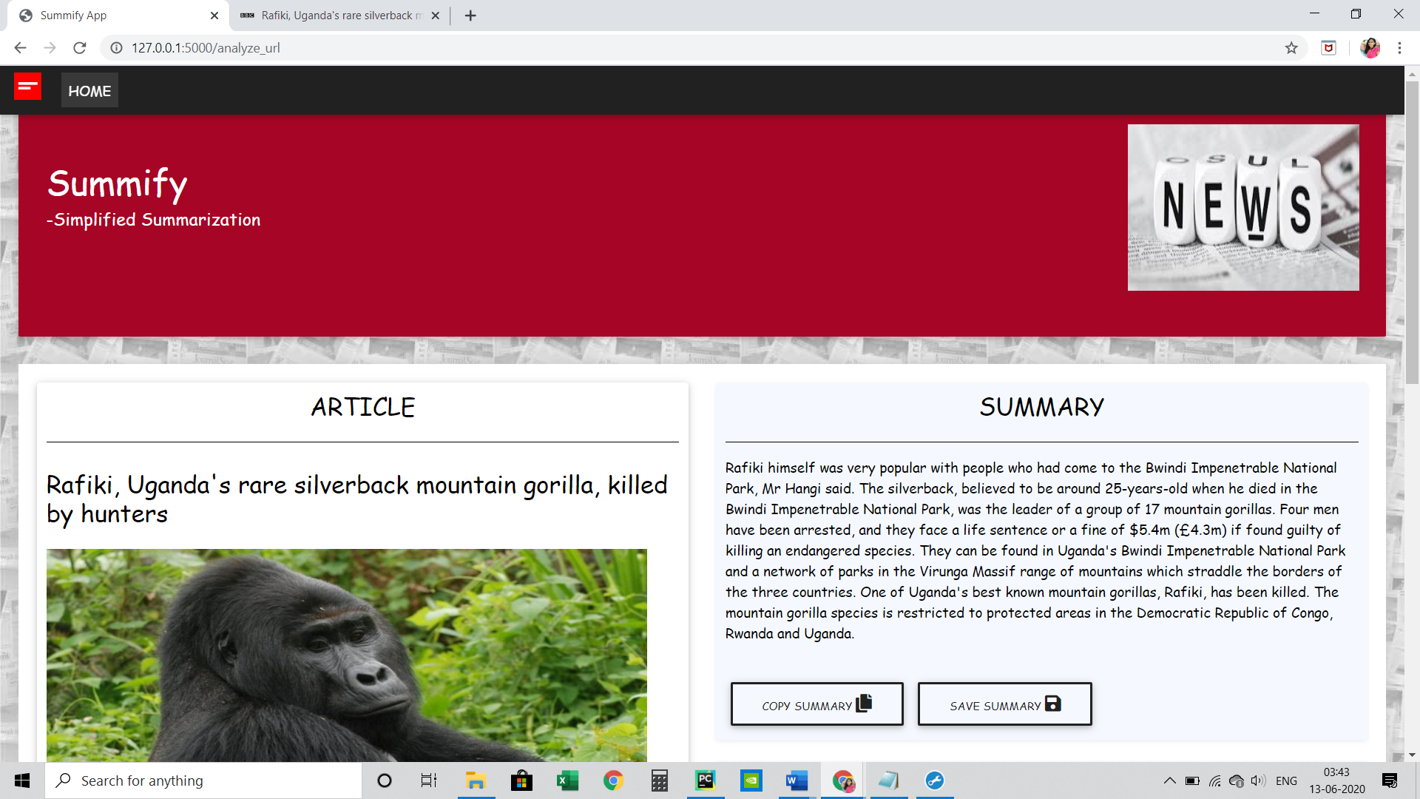

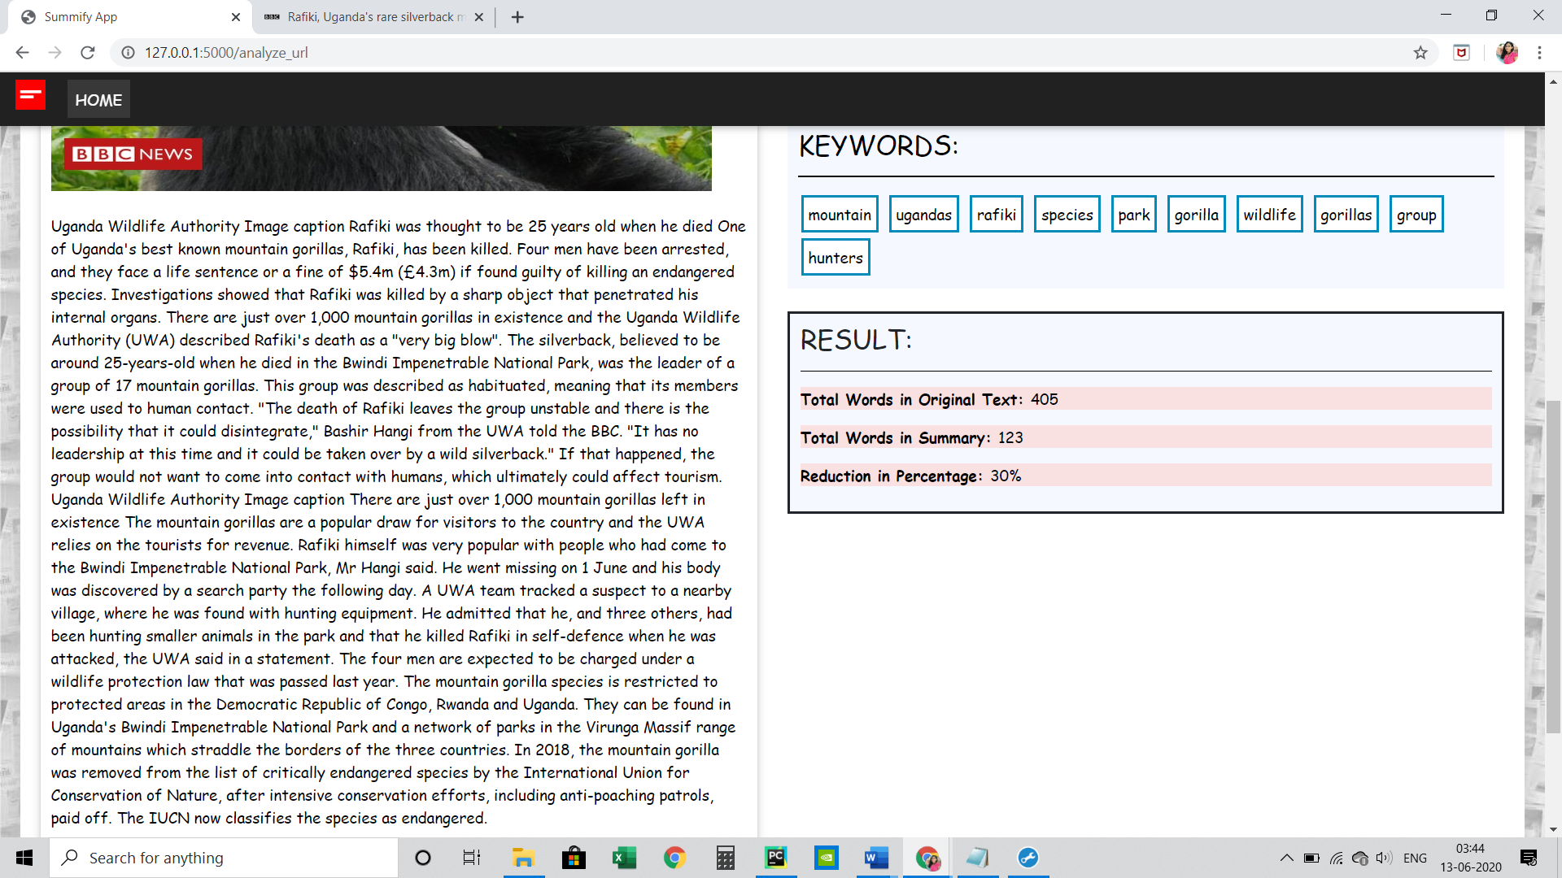

**REUTERS NEWS ARTICLE**

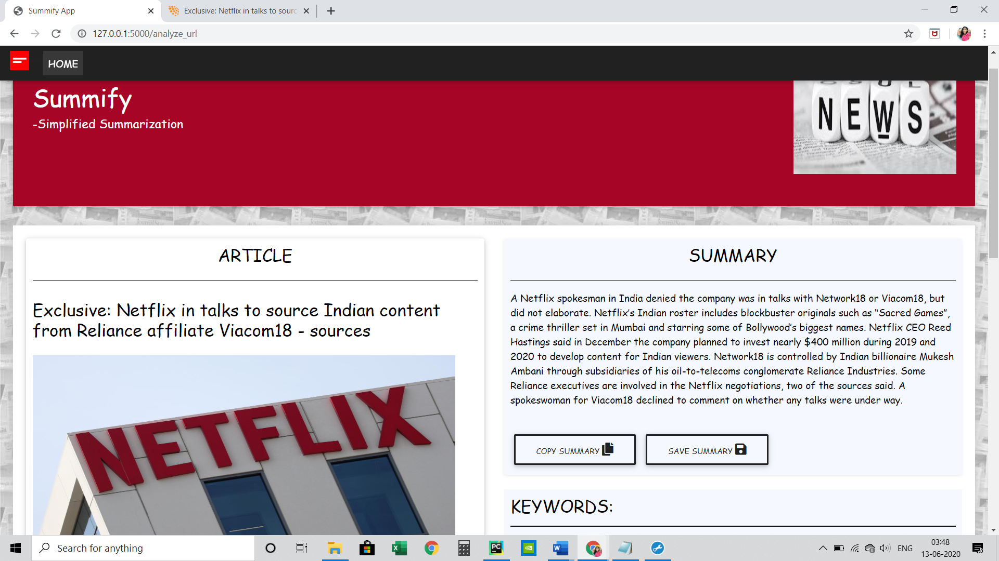

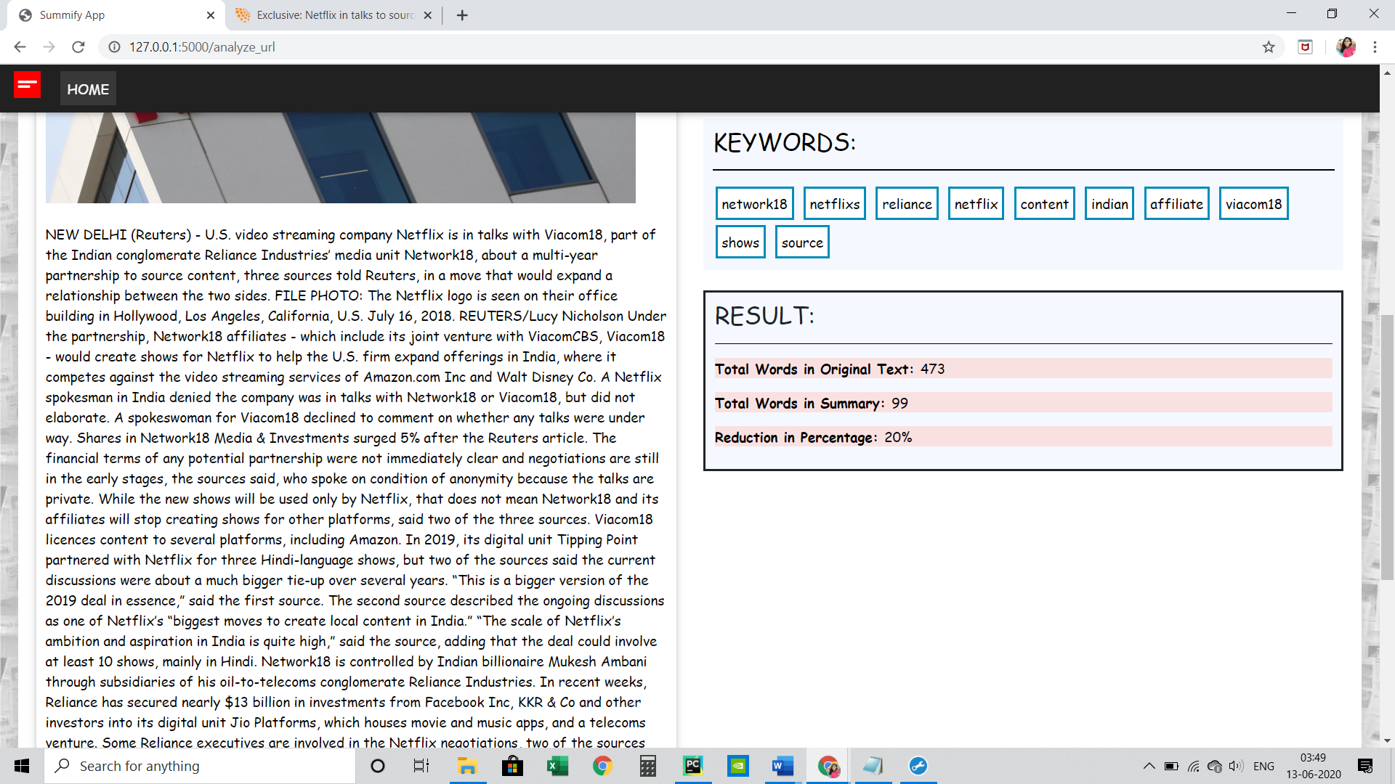

**THE NEWYORK TIMES**

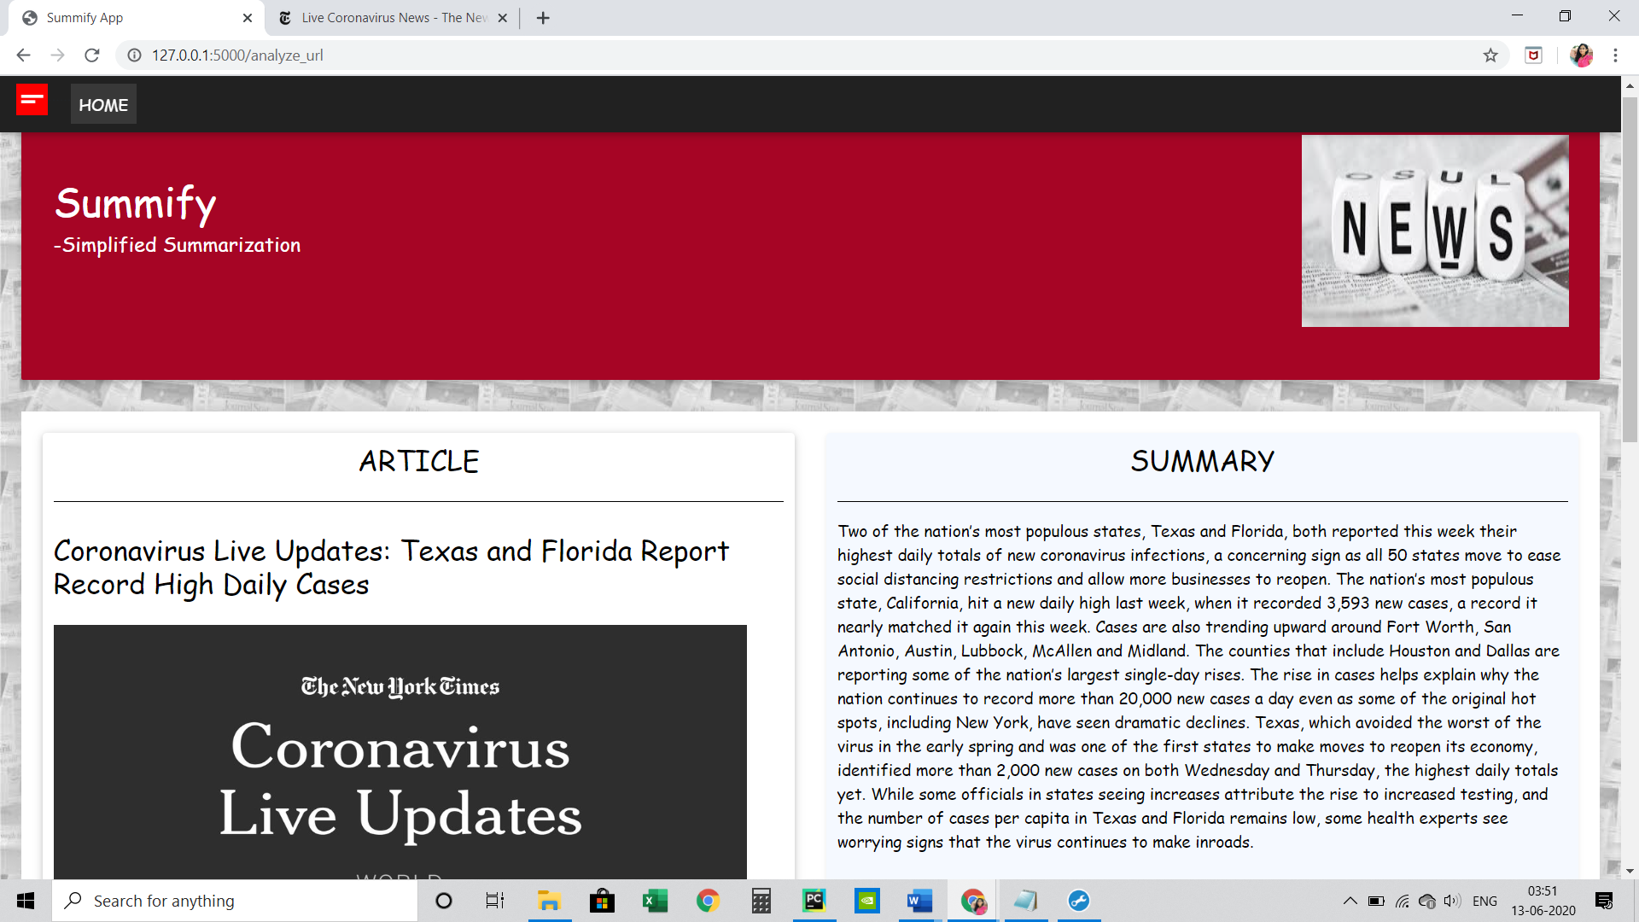

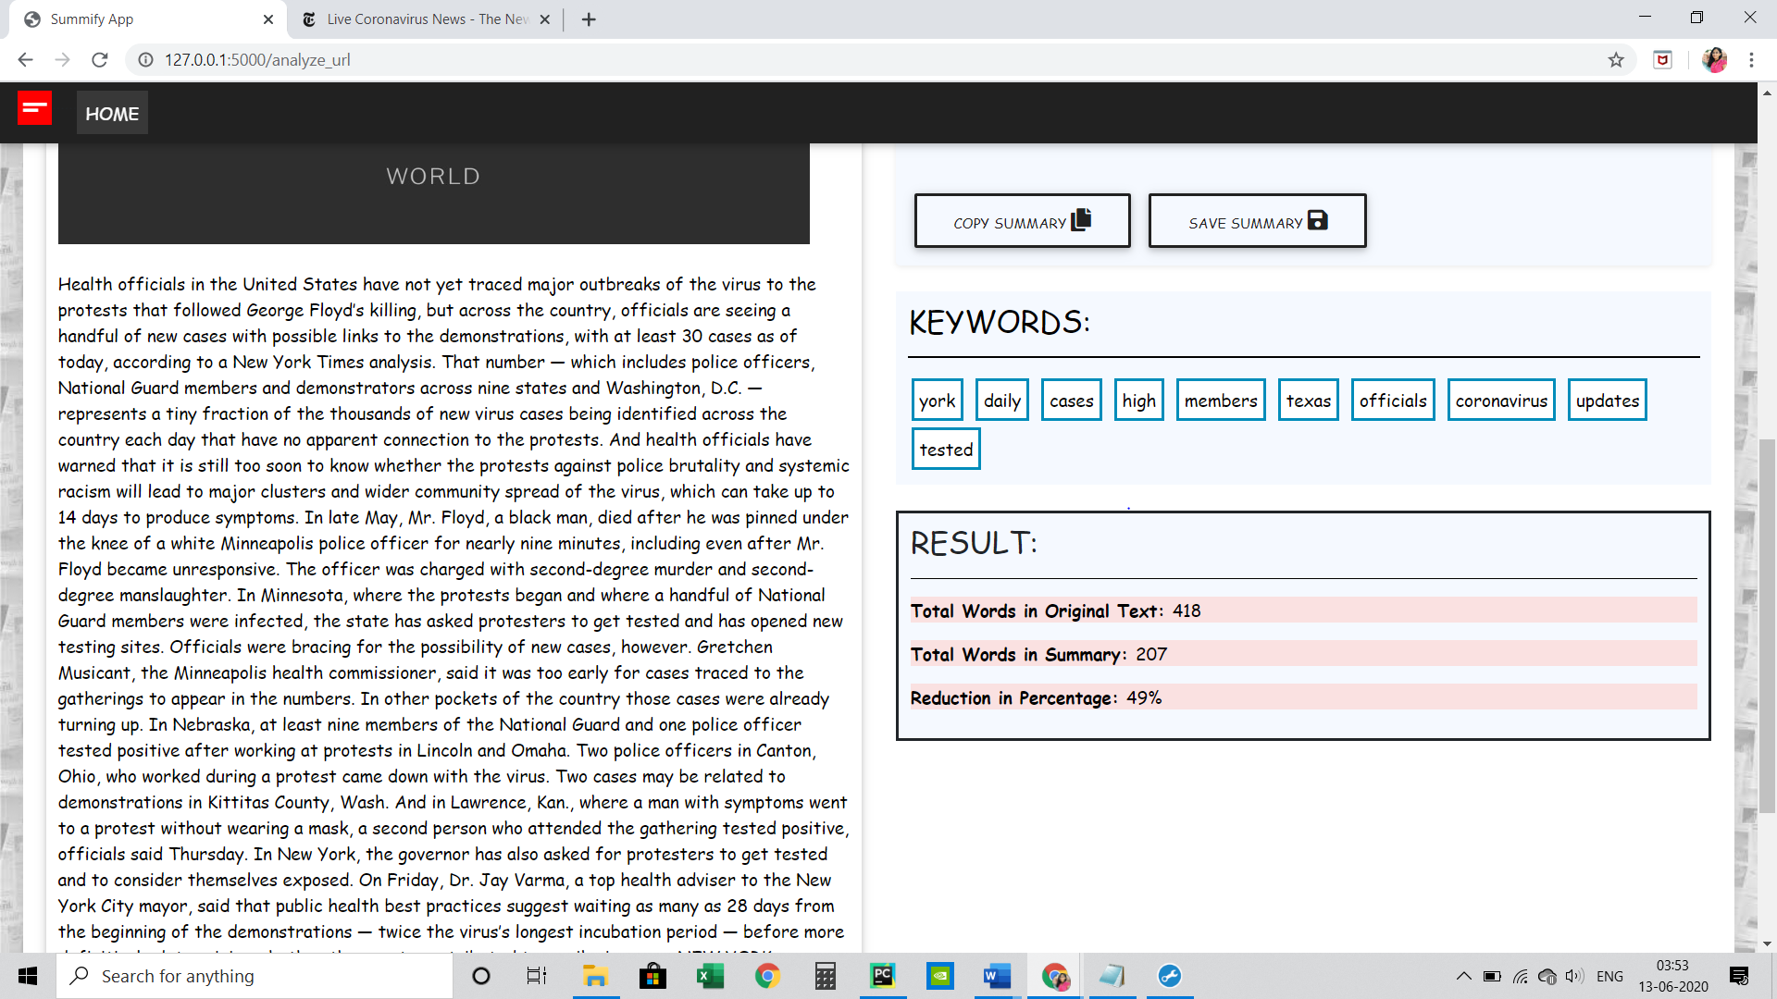

1. **Contact Us Page:**

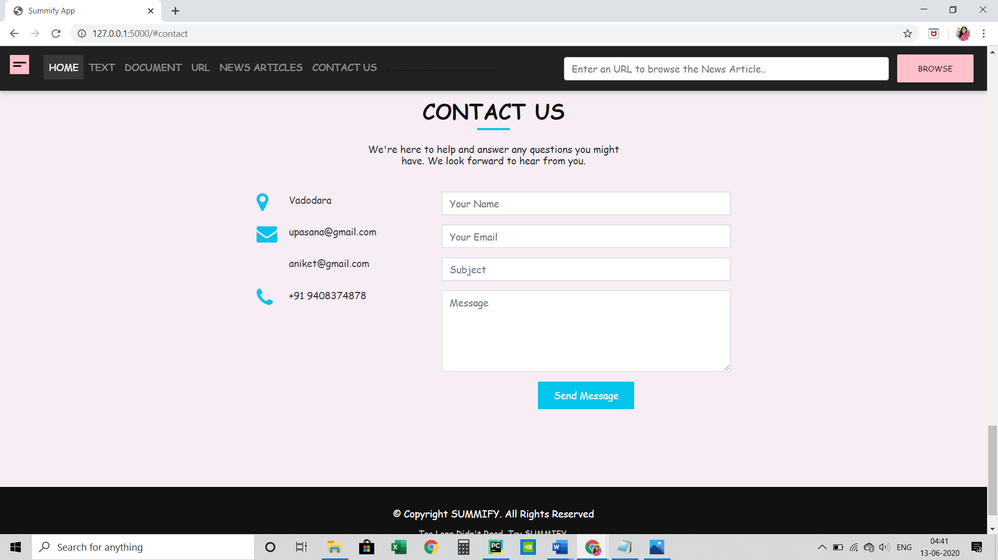

**7.2 ANDROID APPLICATION**

**(1) Home Page:**

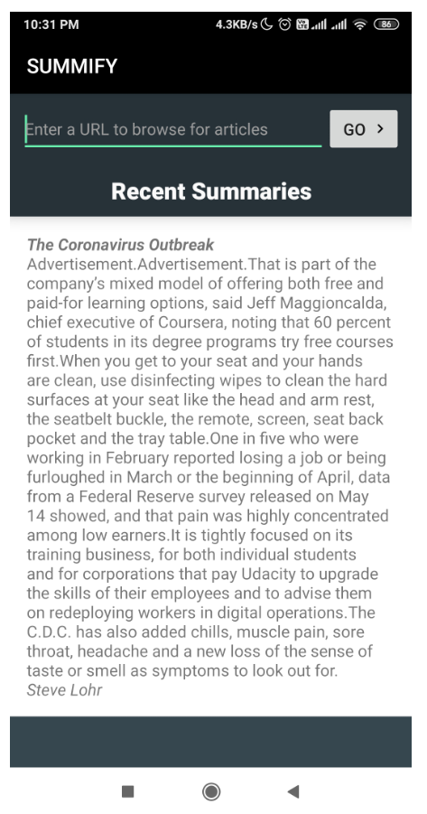 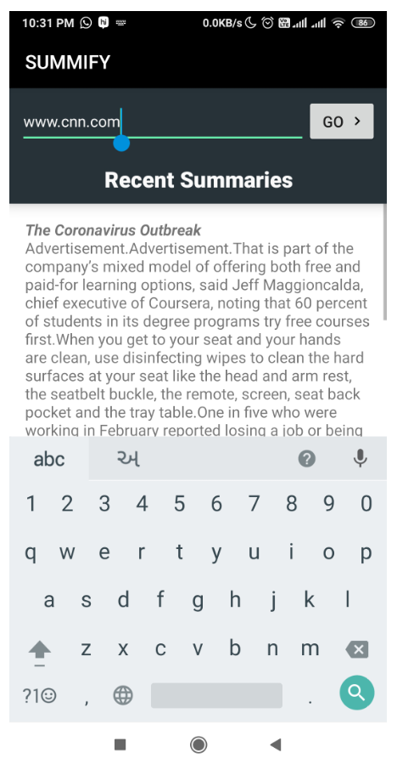

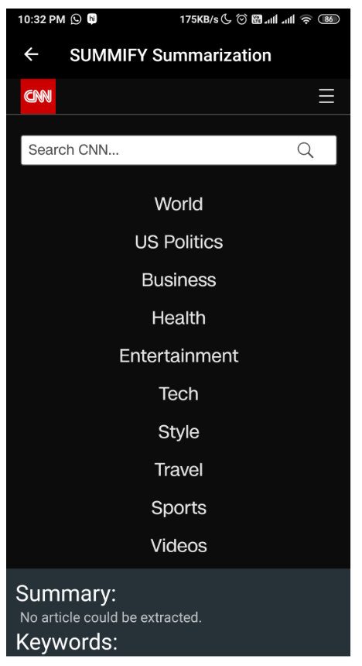

1. **News Article with Summary and Keywords**

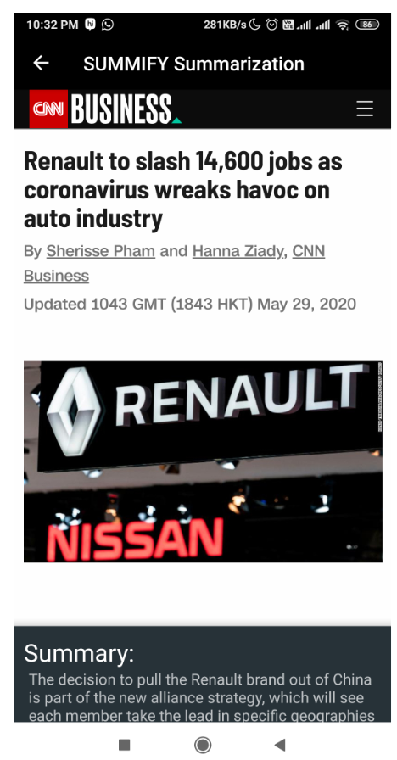 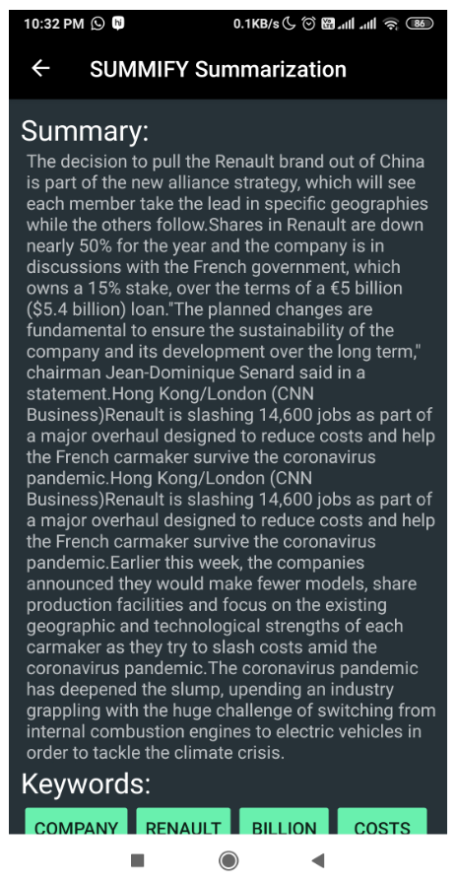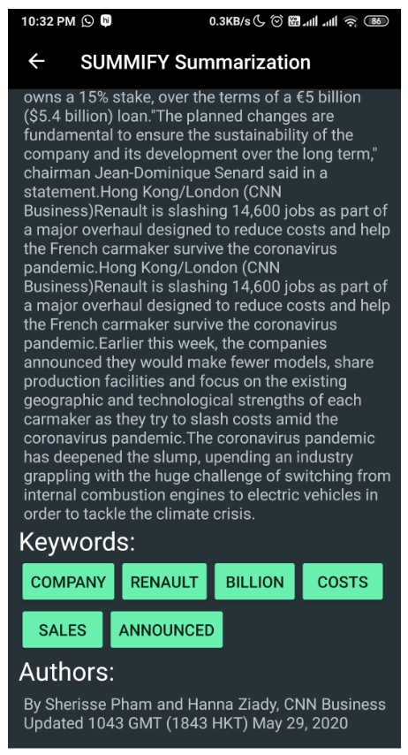

* **Feature of Summify Application:**
* User friendly Interface.
* Displays whole news article along with Summary.
* It also displays top 6 keywords
* Gives Authors Information.
* 15- Most Recent news article along with summary are cached.
* News Articles from various news website can be summarized like CNN, Reuters, The New York Times, etc.
* Generated Summary can be shared with anyone on social media.

**8. CONCLUSION**

Text summarization is an interesting machine learning field that is increasingly gaining traction. As research in this area continues, we can expect to see breakthroughs that will assist in fluently and accurately shortening long text documents. Thus text summarization is need and used by business analyst, marketing executive, development, researchers, government organizations, students and teachers also. We have developed an extractive method for text summarization. It is specially developed for News Summarization as it is designed for single news article summarization. It selects the best sentences among the news article by calculating its different features score and selects among the top scored sentences along with top keywords. We have developed a web application using flask and a android application as final product called Summify. We have used our developed algorithm to generate summary of different websites of news articles in our application. The web application not only provides summary of input news article but also provide different input options like text, URL and document for multipurpose use. The future work extend would be to increase the accuracy and can summarize multiple news article. Also, we would like to implement this approach to generate news summary for different languages. So, that everyone can be a part of this system.

**REFERENCES**

1. Automatic text summarization using a machine learning approach, Neto, Joel Larocca and Freitas, Alex A and Kaestner, Celso AA, Brazilian Symposium on Artificial Intelligence
2. A. McCallum and K. Nigam, “A comparison of event models for Naïve Bayes text classification,” in Proceedings of AAAI Workshop on Learning for Text Categorization, 1998, pp. 41-48.
3. Babar S.A. and Thorat S.A., “Improving Text Summarization using Fuzzy Logic & Latent Semantic Analysis”, International Journal of Innovative Research in Advanced Engineering (IJIRAE), 2014, Vol. 1 Issue 4
4. Document clustering: TF-IDF approach, Bafna, Prafulla and Pramod, Dhanya and Vaidya, Anagha, Electrical, Electronics, and Optimization Techniques (ICEEOT), International Conference on, Pg-61-66,2016
5. D. Shen, et al., “Web-page classification through summarization,” in Proceedings of the 27th Annual International Conference on Research and Development in Information Retrieval, 2004, pp. 242-249.
6. E. Gabrilovich and S. Markovitch “Text categorization with many redundant features: using aggressive feature selection to make SVMs competitive with C4.5,” in Proceedings of the 21st International Conference on Machine Learning, 2004, pp. 321- 328.
7. E. Hovy and C. Y. Lin, “Automated text summarization in SUMMARIST,” Advances in Automatic Text Summarization, 1999, pp. 81-94.
8. H. P. Luhn, “The automatic creation of literature abstracts,” IBM Journal of Research and Development, Vol. 2, 1958, pp. 159-165.
9. Karmakar Surajit, Lad Tanvi, Chothani Hiten, “A Review Paper on Extractive Techniques of Text Summarization”, International Research Journal of Computer Science (IRJCS), Issue 1, 2015, Vol. 2
10. Kolcz, et al., “Summarization as feature selection for text categorization,” in Proceedings of the 10th International Conference on Information and Knowledge Management, 2001, pp. 365-370.
11. Mallett Daniel, Elding James, Nascimento Mario A., “InformationContent Based Sentence Extraction for Text Summarization”, Proceedings. ITCC 2004. International Conference on, 2004,Vol. 2.
12. Saranyamol C S, Sindhu L, “A Survey on Automatic Text Summarization”, International Journal of Computer Science and Information Technologies, 2014,Vol. 5 Issue 6.
13. Suneetha Manne, Zaheer Parvez Shaik Mohd. , Dr. S. Sameen Fatima, “Extraction Based Automatic Text Summarization System with HMM Tagger”, Proceedings of the International Conference on Information Systems Design and Intelligent Applications, 2012, Vol. 132, P.P 421-428.

**APPENDIX-A**

**PERIODIC PROGRESS REPORT (PPR)**

1. ANIKET PATEL(160950107055)

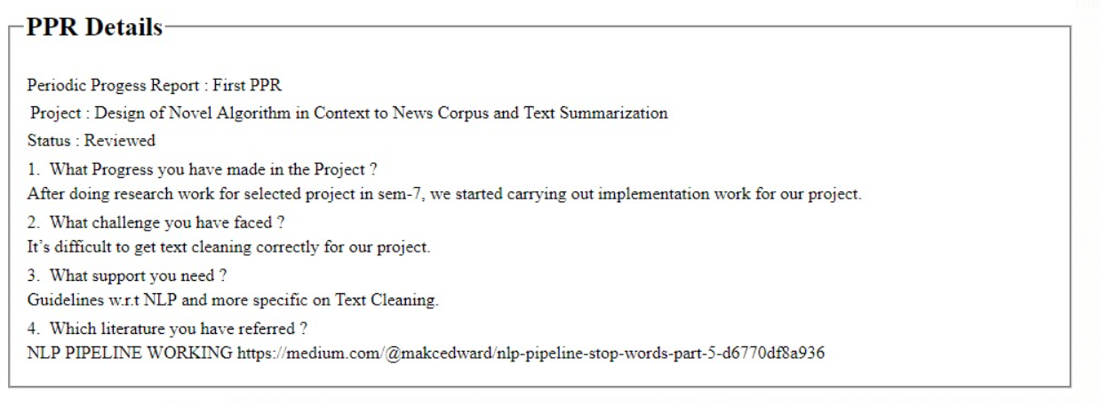

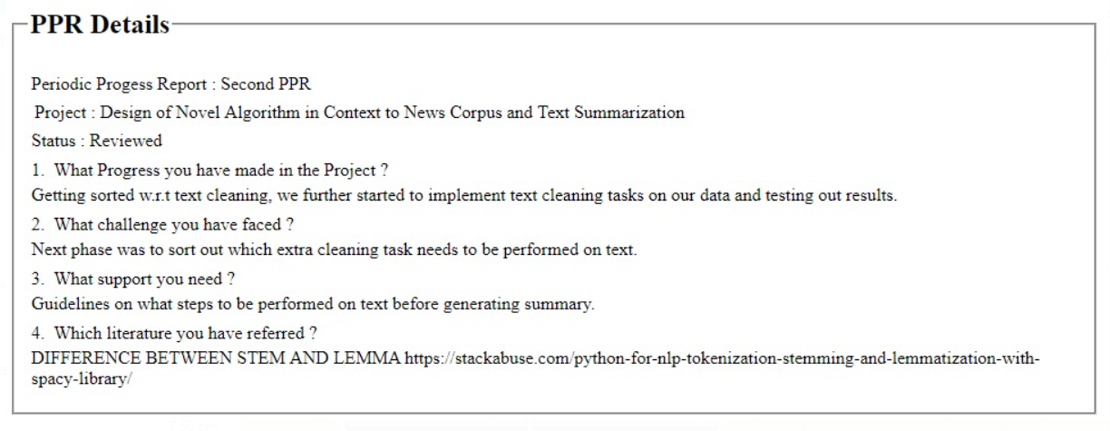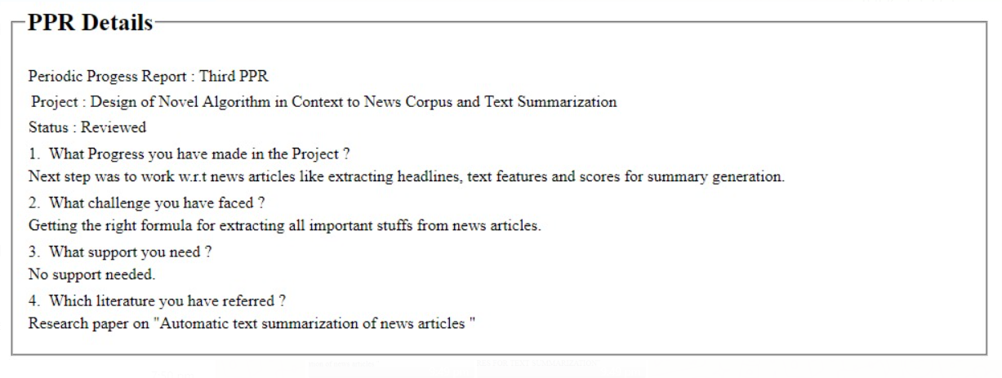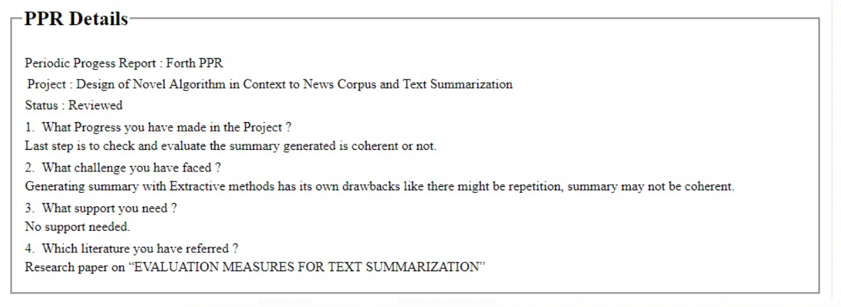

1. UPASANA KALRA(160950107033)

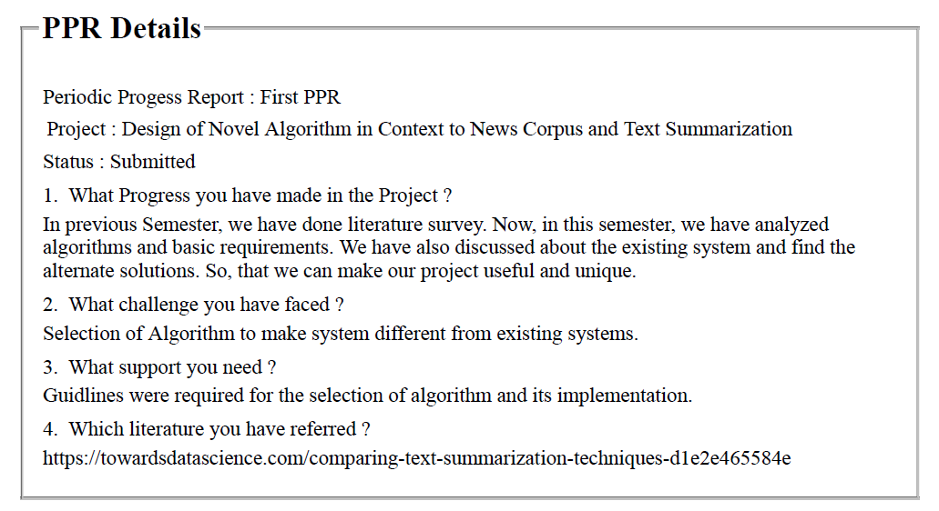 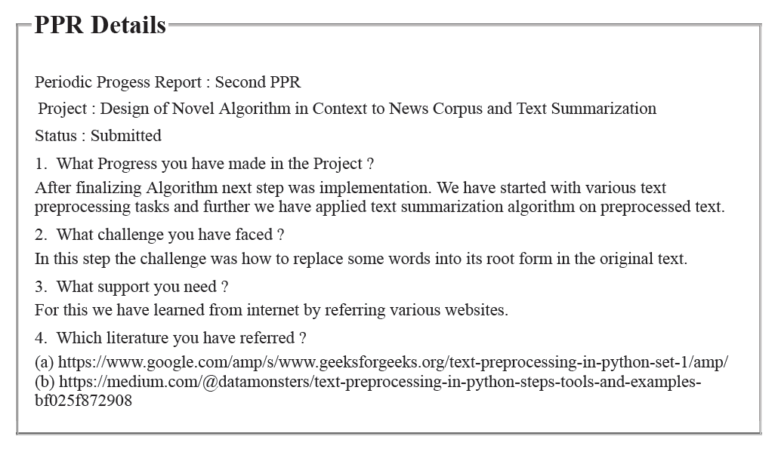 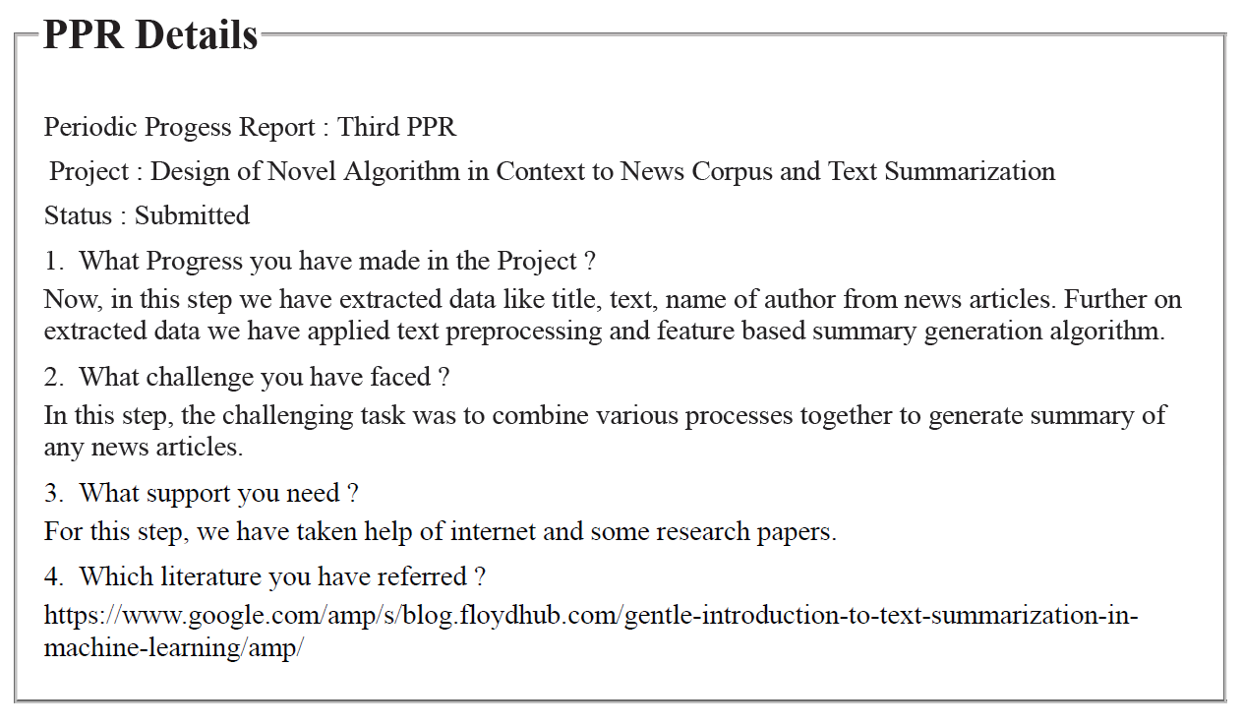

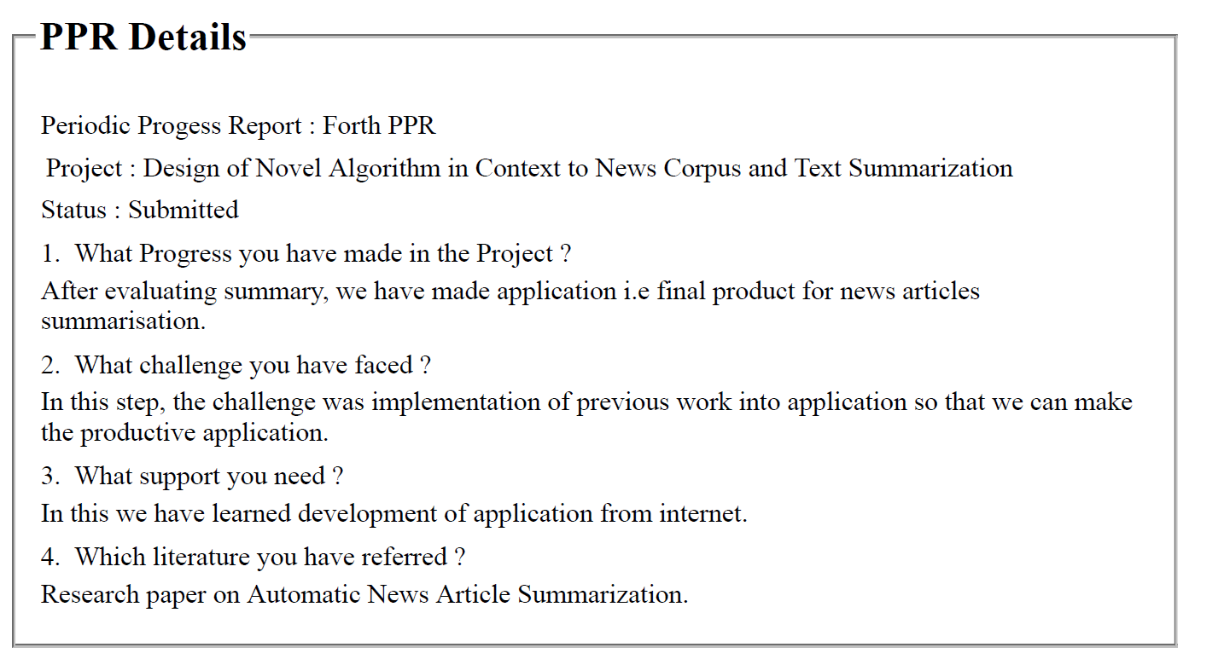

**APPENDIX-B**

**PATENT DRAFTING EXERCISE (PDE)**

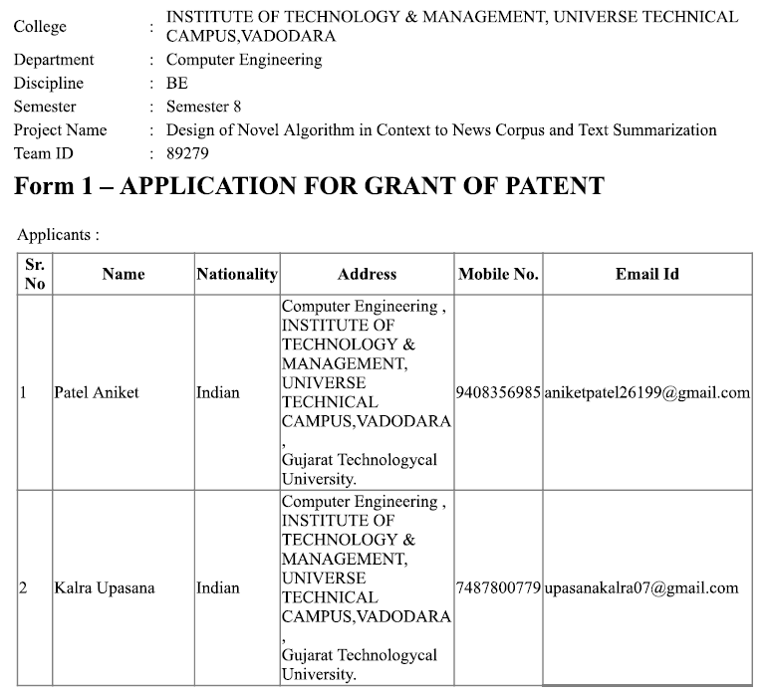 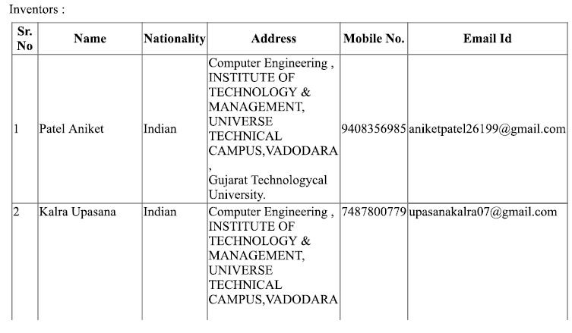 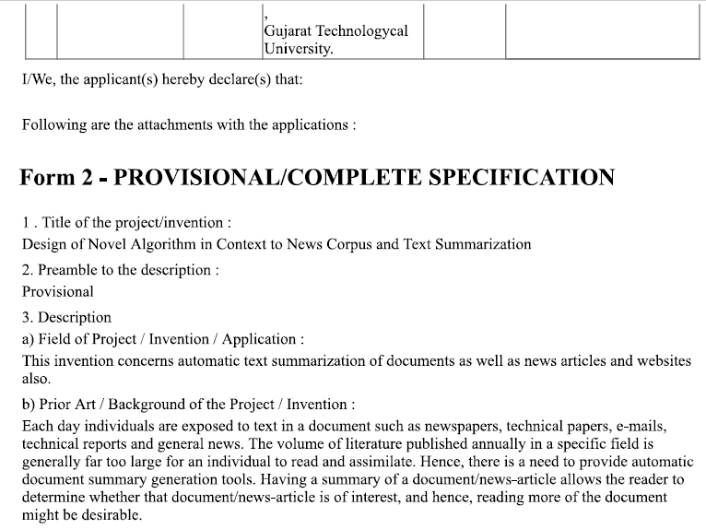 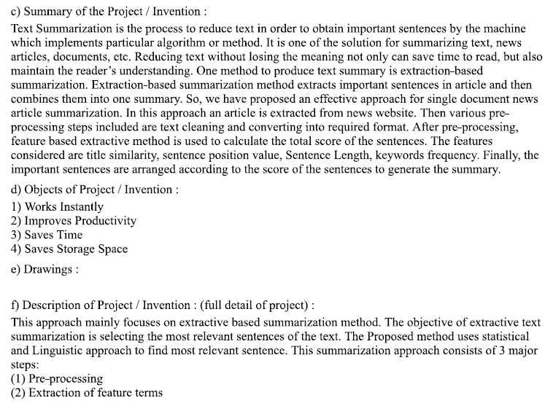 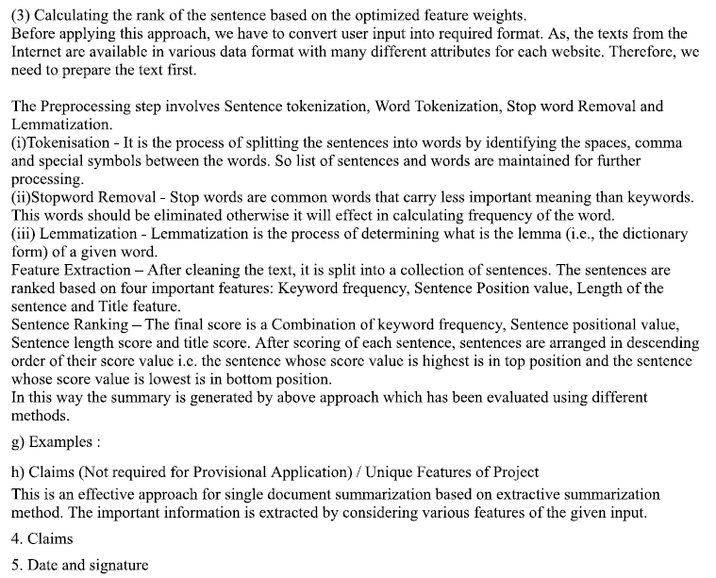 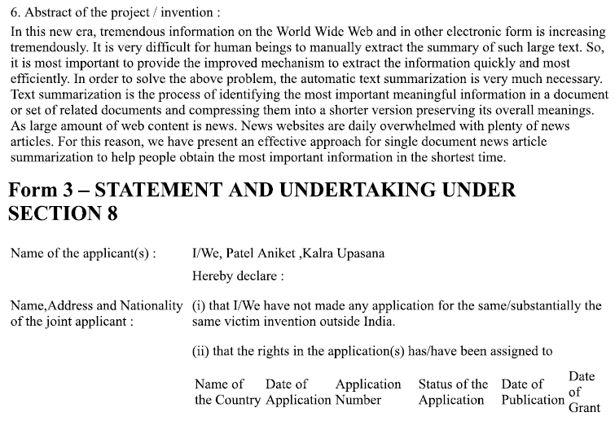 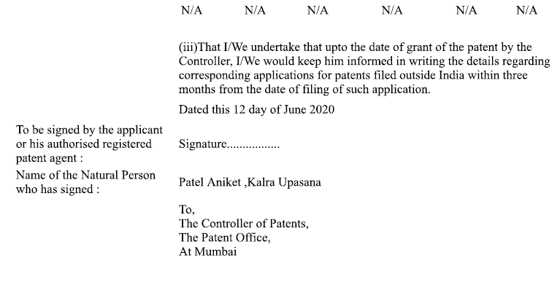

**APPENDIX-C**

**AEIOU SUMMARY**

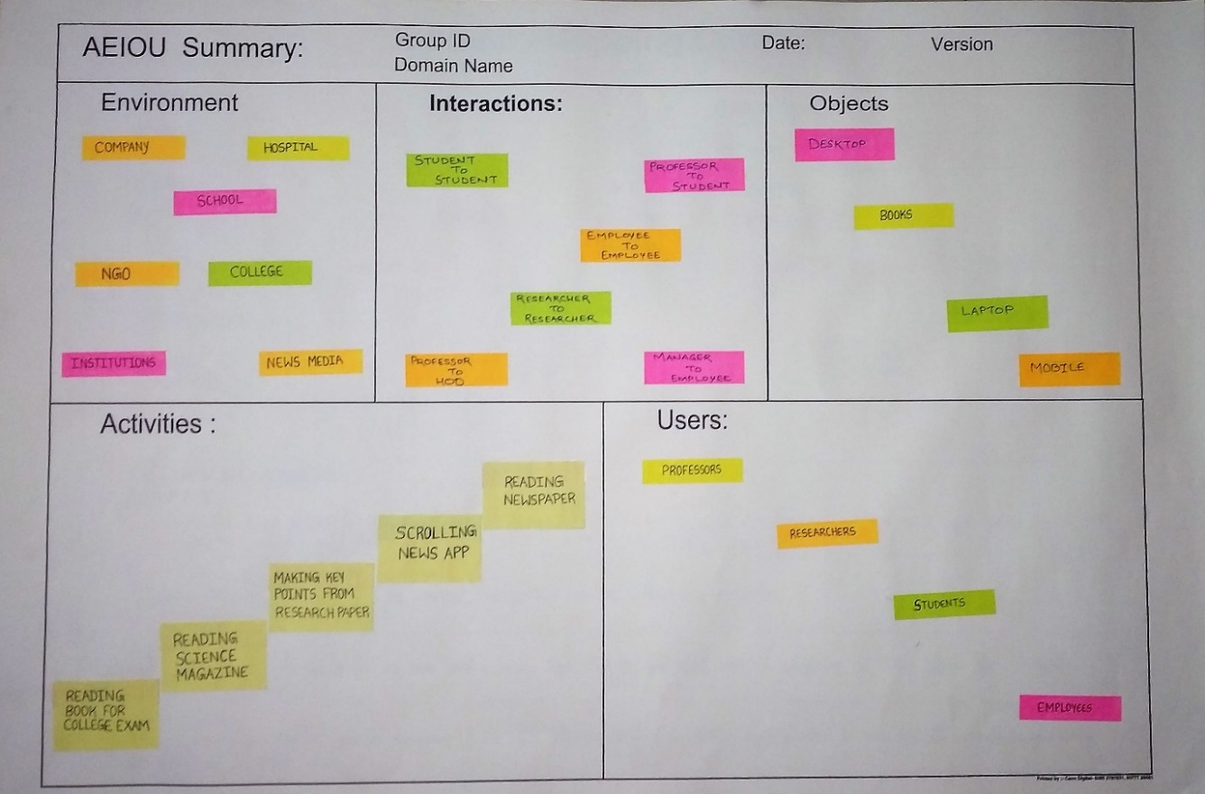

**EMPATHY CANVAS**

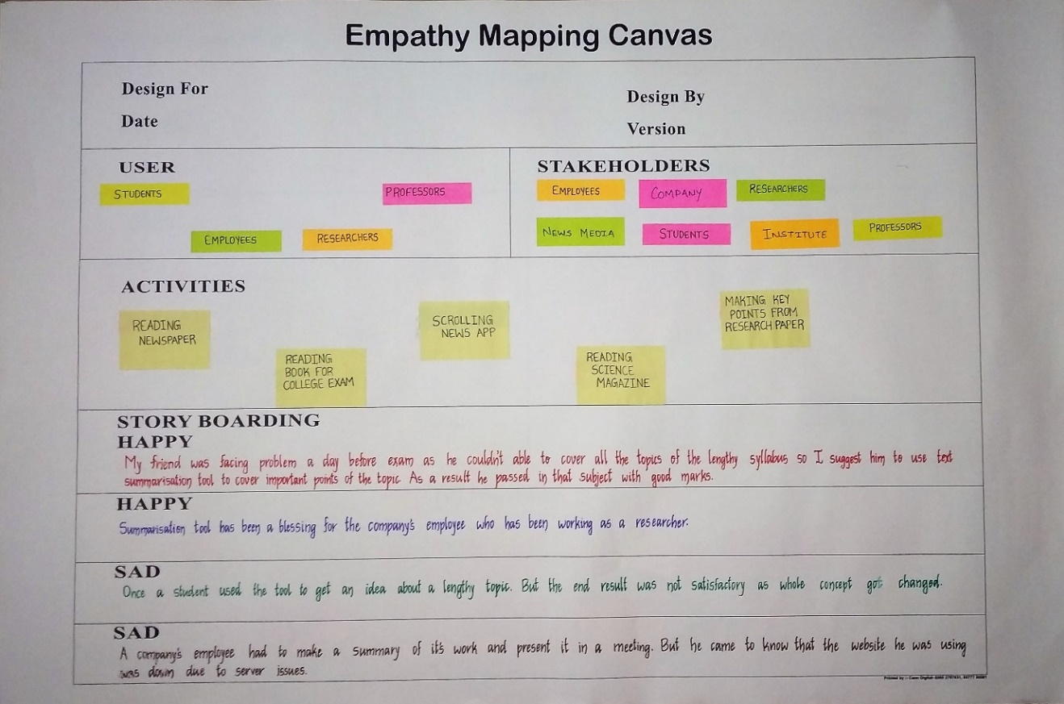

**IDEATION CANVAS**

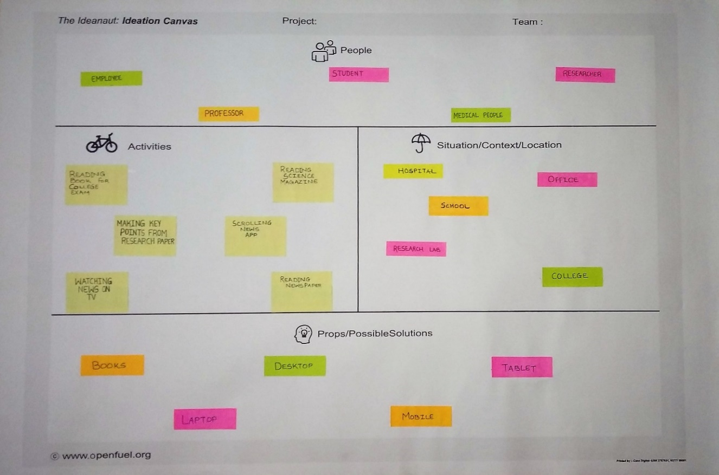

**PRODUCT DEVELOPMENT CANVAS**

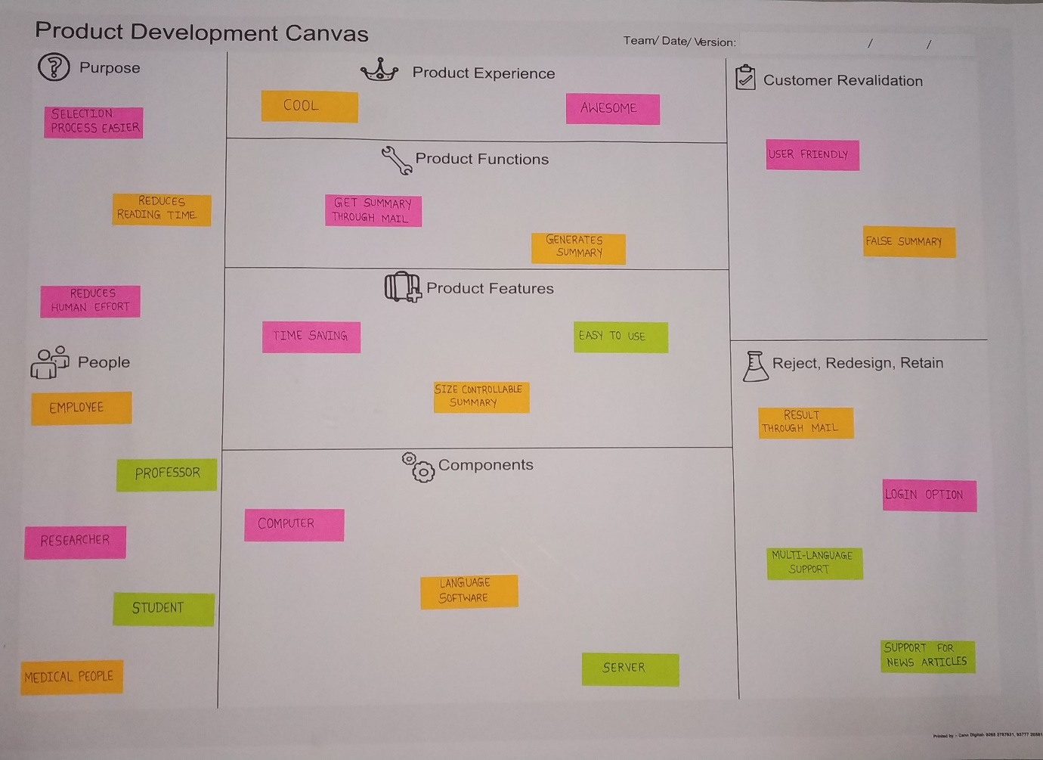

**BUSINESS MODEL CANVAS**

